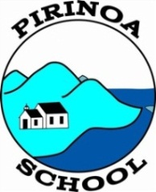
Pirinoa School ~Vibrant and Successful learning
Te kakama, te momoho o te ako

Newsletter ~ 30th June 2017 Week 9 Term 2
Principal ~ Matt Jackett Tel: 063077829
Email: office@pirinoa.school.nz
“You will think it’s paradise!” My Principal told me this, as I passed my resignation letter to him last term. We’re only nine weeks in, but Pirinoa is starting to feel like home and in fact a paradise for Monique and myself. Maybe there’s something in the water?

A big thanks goes out to all of the parents for their support this term. Whether it be for a sports trip, community event, working bee, or flipping patties on the BBQ. The time you have taken to help our students goes a long way. Many of these parents are also on the Board of Trustees. This is a busy and very important job that takes you away from your families. I appreciate the support you give to the school and the time you spend with me working out the important issues.

We also have two local legends named Trish and Mr Bargh who are volunteers at Pirinoa School. They have worked with our students and added value to the learning programmes we offer at school. Trish even asked me for a day off because she is travelling to Australia! Permission granted.

Mrs Batty has had a busy term in the office helping me learn the school systems, as well as sharing many celebrations with her family. Miss Woodhouse and Ms Pickering have been amazing teachers to work with, because of their willingness to work collaboratively for the benefit of our tamariki. I can also count on Angela and Janie to go beyond their job descriptions, to help make this school exceptional. Amanda has done a great job at keeping our school sparkling clean and healthy. Thank you Bruce for keeping your standards high and the lawns low.

Welcome to our new students, Vincent and Melesia! Students, you have all worked hard this term and learnt many things. The seniors have risen to the challenge of being leaders of the school and have led by example. I often see our older students joining in with the juniors and putting other students ahead of themselves. Watching these moments is what makes working in schools special to me. My advice to everyone would be to smile at our mistakes and not be afraid of them; because it is our mistakes, which give us opportunities to learn. The special feeling of learning something, is a feeling we should treasure.

I hope you all get many positives out of the reports today and interviews next week.
I look forward to working with you next term.
Matt Jackett
Things coming up
*Reports have been handed out today *Interviews are next week *Beach tidy up in Ngawi on Tuesday *Planting Day at Lake Ferry on Wednesday has been postponed *Free BBQ to celebrate the term and PB4L next Friday
*End of Term next Friday!

JUNE
MONDAY | TUESDAY | WEDNESDAY | THURSDAY | FRIDAY | SATURDAY |  | SUNDAY
BOT meeting 26  5.45pm | Yr 7/8 Tech 27  Yr7/8 Speech com | Eco Hero 28 | 29 | 30  Newsletter | July 1 |  | 2
JULY
3 | Yr 7/8 Tech 4  Reg. X country  Parent/ Teacher interviews | Parent/ 5  Teacher interviews | 6 | End of 7  Term 2 | 8 |  | 9
10 | 11 | 12 | 13 | 14 | 15 |  | 16
17 | 18 | 19 | 20 | 21 | 22 |  | 23
Term 3 begins 24 | Yr 5/6 RIPPA 25 | 26 | 27 | 28 | 29 |  | 30

Did you know:
- SAUSAGE SIZZLE:
7th July – Sara Sutherland
**Please find attached a new roster for Terms 3 and 4. It would be great if EVERY family could take a turn. We really appreciate your support with this as the funds raised are used for your children. Thank you.
- YR 7 & 8 TECH FEES are due now please. You are able to pay by instalments, however, as Terms 1 and 2 have been completed we would appreciate that amount to start with, i.e. $28-75.
PARENT TEACHER INTERVIEWS: We have endeavoured to accommodate everyone’s times however some times have proved more popular and we have had to alter things slightly. If you cannot make the time allotted to you, please contact the office to make an alternative time. Thank you.
ROOM 3
ROAR – By Kassie Boyle.
Dinosaurs lived hundreds of years ago. Paleontologists are very good at finding dinosaur bones and I like them. Fossils are formed in different ways. Mud and sand combine and make sediment. The sediment buries the object and presses it down, turning it into a fossil.

ROOM 1
This week we went to see Mr Eco at Kahutara School. Mr Eco performed some great raps about saving the planet by putting our rubbish in the bin and using less plastic bags and straws. The children went back to school and enjoyed listening to more of his songs. We have a trip planned for next Tuesday 4th July to Ngawi to help clean up our environment. A new notice is being sent home today as I put the wrong date on it. Please return by Monday 3rd July.
Ms Pickering.

SCHOOL NOTICEBOARD
Make sure you check out our school noticeboard for lots of holiday activities and upcoming events.
ROOM 2
WHAT IS PAPER MADE OF? – By Indy Williams.
Paper is made of wood and wood comes from trees, so basically paper is made of trees. Well, 93% of paper is. As we talk, more than 199 TONS of paper has already been made. 10 litres of water is used to make 1 piece of A4 paper. Recycling 1 ton of paper saves somewhere around 682.5 gallons of oil, 26,500 litres of water and 17 trees. US offices use 12.1 trillion sheets of paper a year.
LOST PROPERTY
Please have a look through the lost property boxes and claim anything that belongs to you. Anything left at the end of the term will be disposed of.
Mr Eco raising student awareness regarding our environment.
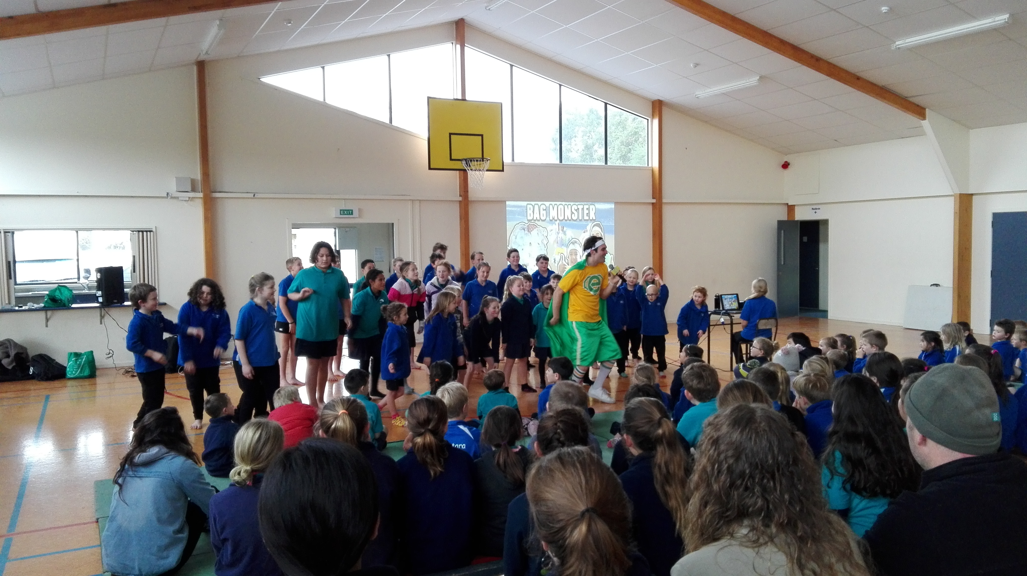
WEEK 9 LEARNING AWARDS

PRINCIPAL’S AWARD: MELESIA ENE -
For showing Maramatanga by showing initiative in the classroom by checking her work with other students before asking questions.

ROOM 2: INDIGO WILLIAMS - For writing a very informative explanation on how paper is made. You researched the information independently and structured your writing with an introduction, main ideas and a conclusion. Well done Indy.

ROOM 1: VIENNA WEATHERSTONE - For helping others in the classroom with I.C.T
problems.

ROOM 3: KASSIE BOYLE - For amazing writing. You listen carefully to discussions about science and have a wriiten a great explanation on how fossils are formed. Well done Kassie.

YEAR 8 PLAYGROUND AWARD: MAIYAH FELLERHOFF – For listening in class.

ROOM 2 NEWS

