Pirinoa School ~Vibrant and Successful learning
Te kakama, te momoho o te ako

Newsletter ~ 25th August 2017 Week 5 Term 3
Principal ~ Matt Jackett Tel: 063077829
Email: office@pirinoa.school.nz
Kia ora whanau
Our findings from the community evening earlier this term have now been summarised by the BOT and teaching staff. Cultural, curriculum implementation, infrastructure, and community connections were highly visible in the ideas that were shared. We unquestionably want our students to be confident, capable and respectful people alongside these goals. There is still time to share your thoughts and opinions via email, phone, or feel free to come and have a chat.
I have recently been to a digital technologies curriculum consultation meeting. In two years time, it is anticipated that every student in New Zealand will be learning about digital technologies during school time. As with most new ideas around the future of education, I believe that it has its merits, but should be introduced gradually and not at the expense of other important curriculum areas.
Pirinoa’s involvement with the Community of Learning is gaining momentum. We have not officially joined yet, but as our COL moves forward with their achievement challenges now being finalised I can see the positive benefits that it will bring to our students.
The water situation is also looking promising. It shouldn’t be too long now until we can have a cool drink of fresh water from our fountains at school. Until then, please help your children by ensuring they have their water bottle filled before they come to school each day.

Events coming up week 5
Miniball every Wednesday night this term. Next week’s game is at 6.00pm –v- SM Blue
Kapa Haka every Monday around 11am
Pirinoa School Science Fair – Week 9, Term 3: Monday 18th September.
South Wairarapa Science Fair Week 10 Tuesday 26th September.
Technology for Year 7/8 students begins next Tuesday – please ensure your tech fees have been paid. Thank you.

Matt Jackett
Principal
Pirinoa School

AUGUST
MONDAY | TUESDAY | WEDNESDAY | THURSDAY | FRIDAY | SATURDAY |  | SUNDAY
21 | BOT meeting 22 | 23 | 24 | Newsletter 25 | 26 |  | 27
28 | Yr 7/8 Tech 29 | 30 | 31
SEPTEMBER
 |  |  |  | 1 | 2 |  | 3
4 | Yr 7/8 Tech 5 | 6 | 7 | Newsletter 8 | 9 |  | 10
11 | SthWai Hockey12 Tournament | 13 | 14 | Tuhirangi 15 JABprizegiving 6pm | 16 |  | 17
Pirinoa Science18  Fair Yr 4-8 | Yr 7/8 Tech 19  Yr 5/6 RIPPA | 20 | 21 | Newsletter 22 | 23 |  | 24
25 | Sth Wai Science26  Fair Yrs 5-8 | 27 | 28 | End of T3 29 | HAPPY 30  HOLIDAYS !!!

Did you know:
- SAUSAGE SIZZLE: 1st Sept: Macdonalds; 8th Sept: Sutherlands. Thank you for your help with this fundraiser.
- SCHOOL WEBSITE: If you ever need any information, or cannot find our school newsletter, go to our school website: www.pirinoa.school.nz On there you will also find events coming up on the school community calendar. Check it out!
- LAMB & CALF DAY Change of date ….Unfortunately, due to Kapa Haka being re-scheduled to week 1 in term 4, we have had to change our Lamb & Calf Day…it will now be held on Wednesday 18th October. All art and craft entries will need to be at school on Tuesday 17th October. Thank you.
- STH FEATHERSTON AG FAIR – Saturday 21st October 10am-2pm (see notice on our noticeboard for more details).

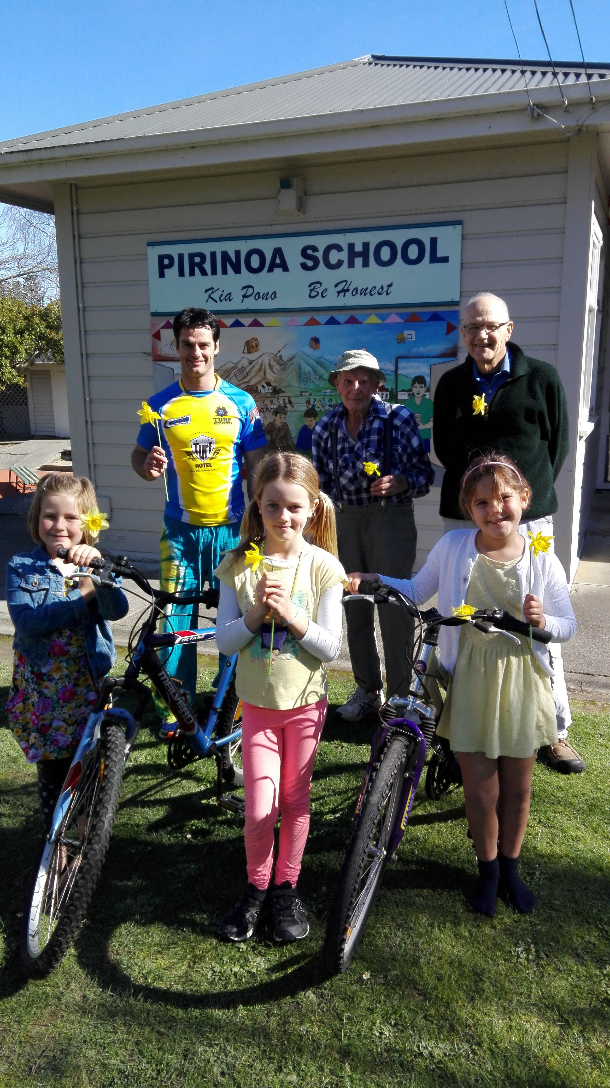
MARTINBOROUGH MENS SHED
The wonderful people at the Mens
Shed have given our school two
more bikes…we are very lucky!
Ric and Jack Priest brought them
Down to school today.
Now we just need helmets…if you
have any spare bike helmets that
you would donate to our school we
would love to hear from you.
Happy, safe riding!
PIRINOA SCHOOL AGRICULTURAL DAY 2017
It’s that time of year again when students need to think about what animal(s) they will bring to our Ag Day, Wednesday 18th October.
The animal categories are:
Pet Lamb, Condition Lamb,
Calves: Ringcraft, Dairy type, Beef type, Care and Handling.
Dogs: Most Loved; Most Obedient.
Pets: Best Cared For; Most Unusual.
Students are allowed to bring more than one animal, i.e. they can have a lamb and a dog, or pet if they wish to. Dogs are not allowed to be off their leashes at any time except judging.
Art & Craft activities: Judging will be done after students have left school on Tuesday 17th October.
Flower arrangement – home.
Vegetable novelty – home.
Baking/cooking – Kiwiana theme – home.
Photography – home.
Masks – these will be made at school.
Students must enter a minimum of 3 art & crafts.
*Entry forms will be sent home in the next few weeks.

ROOM 1 STORIES
How the tiger got its stripes – By Heidi.
A long, long time ago there was a tiger but there was one problem, every night he was cold. So he set off to look for a house and on the way he met a man. He asked him, “Do you know a house I can live in?” But the man said, “No, but you can build one.” So the tiger found some sticks so he built them on top of him. They stuck to him. That was how the tiger for his stripes.

How the snake got his tongue – By Willow.
Once upon a time there was a snake who wanted to talk but he had no tongue so he went to the lolly shop to get some licorice and stuck it on. Now he can talk to all his friends and can eat and he can hold things too.

ROOM 2 – by Aria Whiteman.
Smoke is a brown, black and white dog. He is very fast and tall, he likes to have big runs .He licks my cousin and she hates it. We met him at White Rock. We went there to stay and he was just a grey fur ball. We got him when he was one.
Smoke likes to bark at strangers when they come past. Smoke is funny when we play soccer. He will jump if you put your hands up. Smoke likes cuddles and when I cuddle him I can feel his ribs and his wet nose on my face.
Smoke has a chain lead because he bit his other one in half. It was Jessie’s lead. She doesn’t try to bite hers in half like Smoke. He likes to get his chain stuck in the pine cone branches.

SCHOOL NOTICEBOARD
Check out our school noticeboard by Mr Jackett’s office for events coming up in the Wairarapa.
Keep collecting Yummy stickers and bring them to school – thank you. We are getting heaps coming in, we may even break our record this year!!

WEEK 5 LEARNING AWARDS

PRINCIPAL’S AWARD: INDIGO WILLIAMS -
For taking pride in everything she does. By getting stuck into her science fair project and making sure she follows the correct testing procedures.

ROOM 2: ARIA WHITEMAN – For following the Pirinoa Path.

ROOM 3: HEIDI DIDSBURY – For fantastic reading!

ROOM1: JAYZIAH TERRY – For learning his Pirinoa Path sign language.

YEAR 8 PLAYGROUND AWARD: JONO DIDSBURY – For being resilient.

ROOM 2 NEWS

