Pirinoa School ~Vibrant and Successful learning
Te kakama, te momoho o te ako

Newsletter ~ 8th September 2017 Week 7 Term 3
Principal ~ Matt Jackett Tel: 063077829
Email: office@pirinoa.school.nz
Kia ora whanau
We have had another exciting two weeks at Pirinoa School!
The whole school continues to make progress as we move towards the Kapa Haka, Science Fair, and Lamb and Calf Day.
It has been great to see our students show Manaakitanga (hospitality) towards both Martinborough and Tuturumuri students who have joined us for Kapa Haka trainings on Monday. As those schools do not currently have a Kapa Haka group, we thought it was fair and reasonable for them to join our group. A special thanks goes out to Jo and Kingi who continue to do an excellent job. We are currently discussing an extra practice for the group after school in the next week or so.
Our senior students have now completed two technology lessons and it was great to hear that Carter was enjoying his spicy meal he created in the food room. The Miniball team had a great win this week, which is testament to all of the hard work they have been putting into their trainings. The senior room is also preparing well for their hockey tournament, which is on Tuesday next week. With other sports such as weekend hockey, netball, and rugby winding down, a big thanks goes out to all of the volunteers who give up their weekends to ensure our children are involved in such character building activities. We even have a student who is refereeing a netball final tomorrow. Good luck Maralyse!
History was made in Room 2 on Tuesday. After some election research the students decided to create their own political parties and run a short campaign. Four students who were party leaders gave speeches and in short time we had a Prime Minister. The leadership group quickly got into action and created the ‘Onesie Day’ to raise money for the ‘Free Ambulance’. It was very promising to see how mature our students were when discussing politics. Even though many children had different views, they were always respectful and thought of what was best for Pirinoa School. Something I believe the ‘adults’ in the Bee Hive could learn from.
I hope everyone has a great weekend.
Matt Jackett
Principal
Pirinoa School
Events coming up week 7 onwards
Miniball every Wednesday night this term. Next week’s game is at 6.00pm
Senior Kapa Haka every Monday around 11am.
Junior Kapa Haka is on Tuesday around 11am.
Hockey Tournament next Tuesday, 12th. (Notice attached for Years 5 & 6 students).
Pirinoa School Science Fair Week 9 Monday 18th September at 1.30pm
District Science Fair Week 10 Tuesday

SEPTEMBER
MONDAY | TUESDAY | WEDNESDAY | THURSDAY | FRIDAY | SATURDAY |  | SUNDAY
 |  |  |  | 1 | 2 |  | 3
4 | Yr 7/8 Tech 5 | 6 | 7 | Newsletter 8 | 9 |  | 10
11 | SthWai Hockey12 Tournament | Miniball 13  6pm | 14 | Tuhirangi 15 JABprizegiving 6pm | 16 |  | 17
Pirinoa Science18  Fair Yr 4-8 | Yr 7/8 Tech 19  Yr 5/6 RIPPA | Miniball 20  6pm | 21 | Newsletter 22 | 23 |  | 24
25 | District Science 26  Fair | Miniball 27 | 28 | Red Nose 29  Mufti Day | HOLIDAYS 30
OCTOBER
 |  |  |  |  |  |  | 1
2 | 3 | 4 | 5 | 6 | 7 |  | 8
9 | 10 | 11 | 12 | 13 | 14 |  | 15
25 | Sth Wai Science26  Fair Yrs 5-8 | 27 | 28 | End of T3 29 | HAPPY 30  HOLIDAYS !!!

Did you know:
- SAUSAGE SIZZLE: 15th Sept: Nicola; 22nd Sept: Sheree. Thank you for your help with this fundraiser.
- SCHOOL WEBSITE: If you ever need any information, or cannot find our school newsletter, go to our school website: www.pirinoa.school.nz On there you will also find events coming up on the school community calendar. Check it out!
- SCHOLASTIC BOOK CLUB: Orders, together with payment due no later than Monday 11th September.
- BUS ARRANGEMENTS: Please ensure you ring before 2pm with any alterations to the bus arrangements for your child. Please do not use Facebook to advise us as this is not always checked. Thank you.
ONESIES MUFTI DAY – FREE AMBULANCE FUNDRAISER
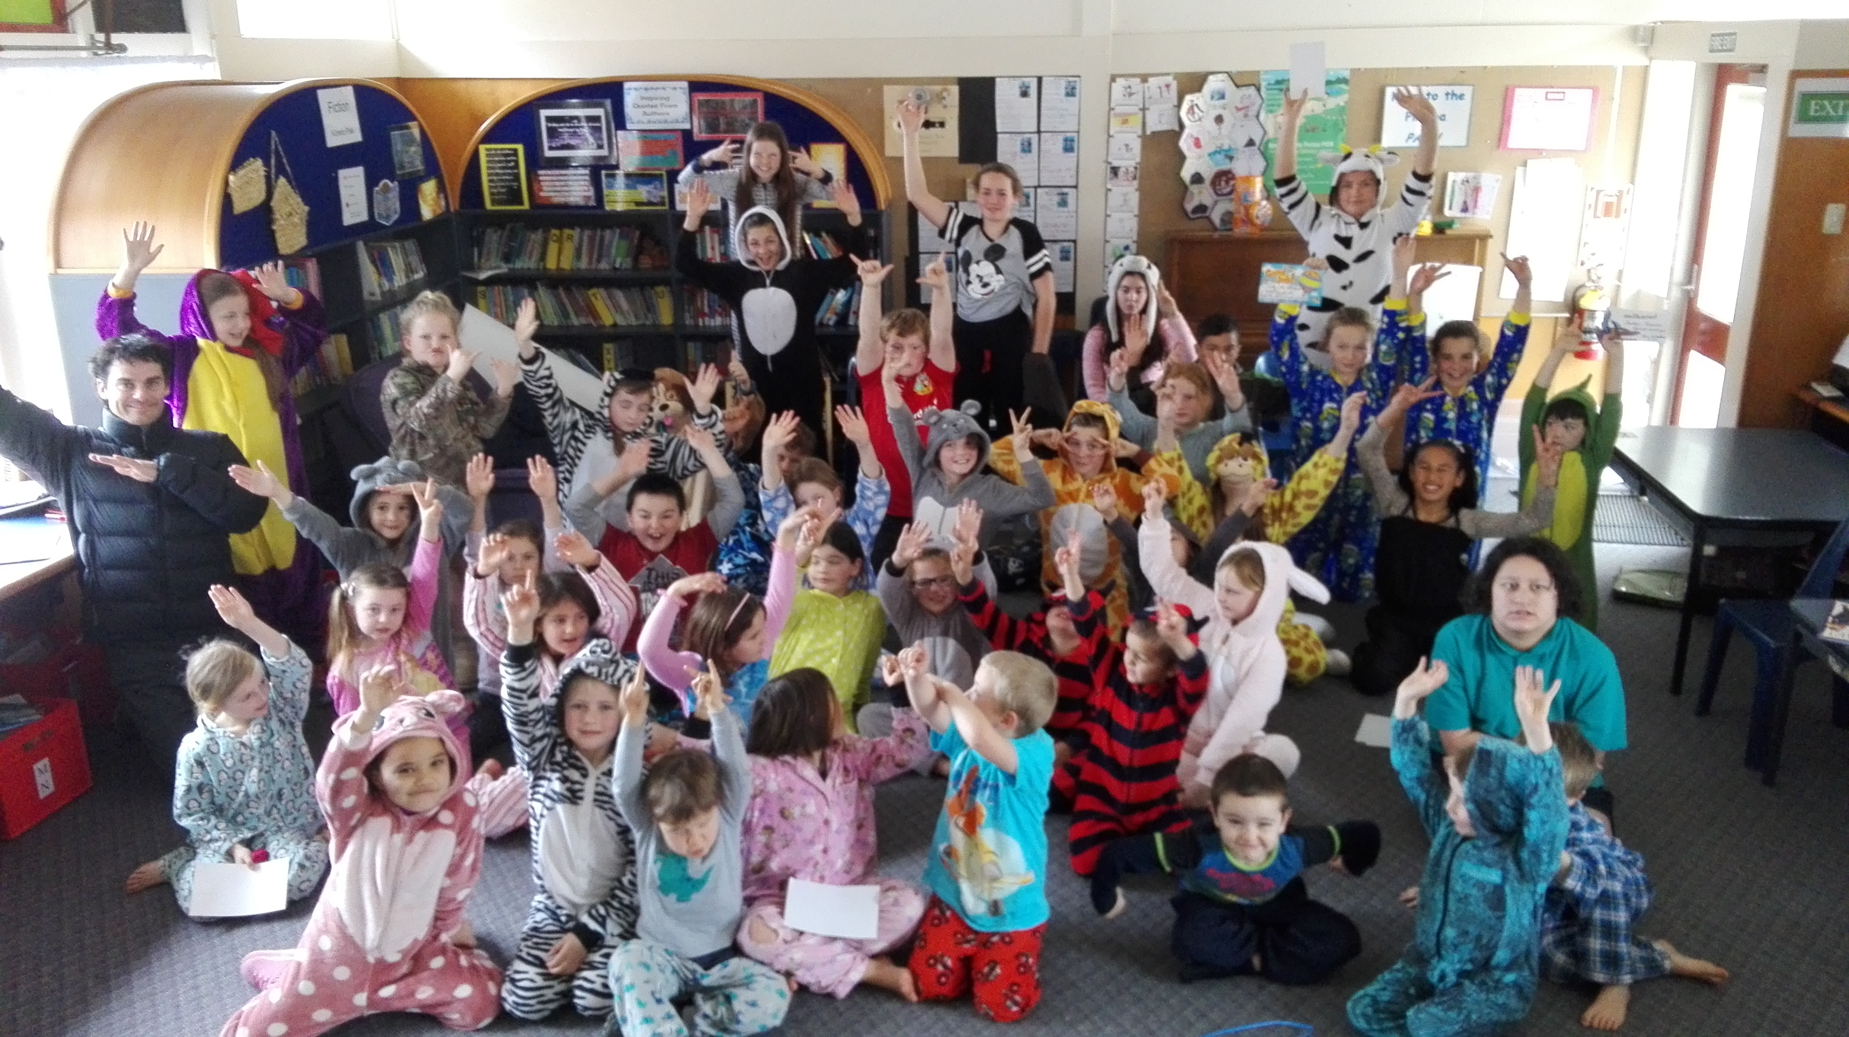
GOOD LUCK …. To the Southern Swans and Southern Stars who have qualified for the finals at their netball. Also to Maralyse who will be umpiring the Grade 5 final. Tremendous effort!!
LAMB & CALF DAY TROPHIES
It’s that time of year where we need to collect the trophies back into the school office. If you received a trophy last year, please ensure it has been polished with Silvo and returned to office no later than 18th September. Thank you.
ROOM 3 STORY – By Jaiden.
A long time ago there was a beautiful princess who was in a cave. She needed help so she went to an old man. The old man saved her because the man was magic and gave her some water and food. Then the princess was really happy! The magic man said, “Do you want me to make a home for you?” The princess said “Yes, please!”
ROOM 1 STORIES
A long, long time ago, there was a princess and the princess went into the cave and the princess got eaten. – By Skye.

A long, long time ago there was a princess who couldn’t get out of the tower. A witch took her into a cave and she got locked in. Then she got turned into a worm. By Jesse.

ROOM 2 – By Nakcha.
Kangaroos, they use their long tails for balancing. The colours of them are grey or brown & white. Their bodies are covered in thick, course, & woolly hair that can shade in grey, or brown or red. The kangaroos
are marsupials, which means that they are females & they carry newborn babies, or, “joeys”, in the pouch in the front of their abdomens.

The LandGirl re-opens next Thursday!!
8am-3pm Thursday to Sunday.
School lunches will be available on Thursdays.
1. Morning Tea & lunch - $10: includes a
Piece of fruit and a muffin, and toasty and hot chocolate.
2. Just lunch - $7.50: includes a toasty and hot chocolate. Text or call in orders before 9am 0272709304.
Loads of new stock for that special gift or some retail therapy. See you soon.
SCHOOL NOTICEBOARD
Check out our school noticeboard by Mr Jackett’s office for events coming up in the Wairarapa.
Keep collecting Yummy stickers and bring them to school – thank you. We are getting heaps coming in, we may even break our record this year!!

WEEK 7 LEARNING AWARDS

PRINCIPAL’S AWARD: LEAH HUME - For being creative and responsible during science

ROOM 2: MARSHALL LOVE - - For finishing your work on time to a high standard. Excellent effort!

ROOM 3: JAIDEN TIOPIRA - For using punctuation in his writing about a princess. Excellent work!

ROOM1: SKYE MACDONALD – For showing leadership in the classroom.

YEAR 8 PLAYGROUND AWARD: HEIDI DIDSBURY – For great participation in learning the Karakia and helping others.

ROOM 2 NEWS

