Pirinoa School ~Vibrant and Successful learning
Te kakama, te momoho o te ako

Newsletter ~ 10th November 2017 Week 4 Term 4
Principal ~ Matt Jackett Tel: 063077829
Email: office@pirinoa.school.nz
Tena kou tou katoa
Pirinoa School continues to grow!
We now have 51 students and are in the process of employing a new teacher for 2018. We will continue to fundraise for small class sizes, and there is a strong possibility that we will have three separate classes running for the entire week next year (not just two days a week like we have this year). This will help make learning and teaching easier for our students and teachers.

The Community of Learning continues to move forward and we are still working through what it will look like for Pirinoa School next year. I have been in meetings discussing the achievement challenges we face as a group of schools and how best to address those challenges.

Thanks to all of those who made it to the Mount Holdsworth meeting last Friday night. Room 2 begins their adventure on Tuesday morning and returns on Thursday afternoon by 2.30pm for the school buses.

Athletics was a huge success yesterday. It was great to see students having lots of fun and giving their absolute best. I always enjoy seeing students supporting other students the most and want to see that continue in the future. We were able to capture some footage and turn it into a short film. Wouldn’t it be great if some of our ICT savvy students learnt how to do this in the future? Also, it was great to see lots of hats on heads. Please ensure your child brings a hat to school every day.
We have had chicken pox going around the school recently. Please keep an eye on your children and take them to the doctor if any symptoms occur.

Our heart goes out to the family of Gaye Didsbury who sadly passed away this week. Gaye has worked with many of our students at Pirinoa School and we are lucky to have had her expertise with us.

Aroha mai, aroha atu
Love towards us, love going out from us
Matt Jackett
Principal

NOVEMBER
6 | 7 | 8 | Cluster 9  Athletics | 10 | 11 |  | 12
13 | Room 2 Camp 14 | R2 Camp 15 | Return from16  Camp. | 17 | 18 |  | 19
School Photos 20 | Yr7/8 Tech 21 | Interschool 22  Athletics | 23 | 24 | 25 |  | 26
27 | Yr 7/8 Tech 28  BOT meeting | 29 | 30
DECEMBER
 |  |  |  | 1 | 2 |  | 3
Yr8 “Moving on 4  Conference” | Yr 7/8 Tech 5 | Reports go 6  home | Parent 7  interviews | Parent 8  interviews | 9 |  | 10
11 | Yr 7/8 Tech 12 | Prizegiving 13 | 14 | End of T4 15 | HOLIDAYS 16 |  | 17

Did you know:
- SAUSAGE SIZZLE: If you are unable to make your rostered day PLEASE arrange for someone else to cover for you.
17th November: Nicola
24th November: Sonya
- SCHOOL BANKING: If you would like your child to take part in school banking, please see Lynette.
- OFFICE HOURS: During term 4 Lynette will not be in the office in the mornings. If there is anything you need to know feel free to leave her a note or a message on the answerphone. Notes may be left in the yellow ASB box beside the office counter. She will check them when she comes in.
- SCHOOL CALENDAR: Make sure you check it out so you can be up to date with activities your children are involved in.
- SCHOLASTIC BOOK CLUB: Orders, together with payment, due to office before Friday 10th November.
Cluster Athletics 2017
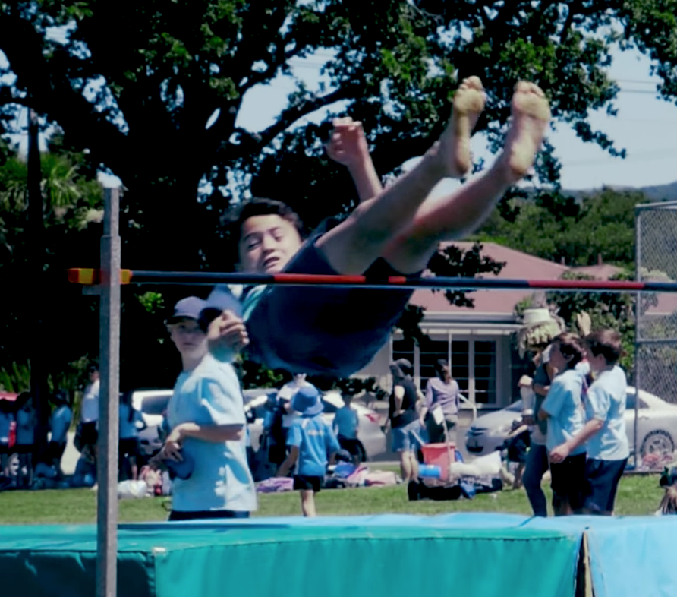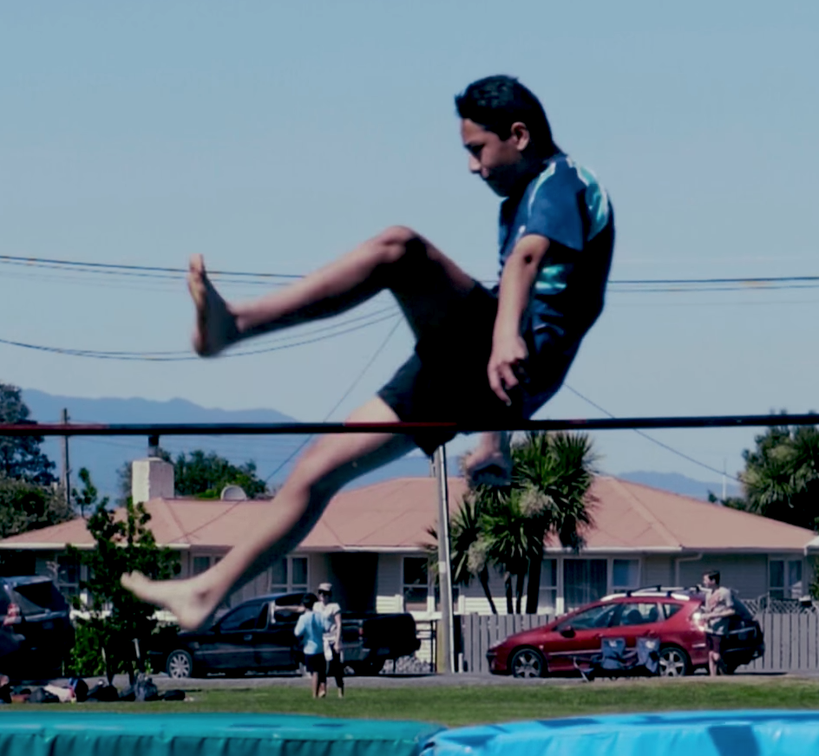
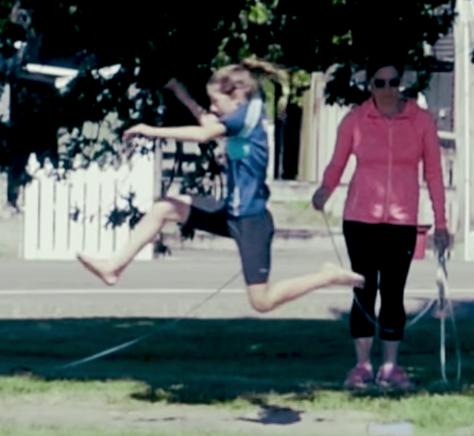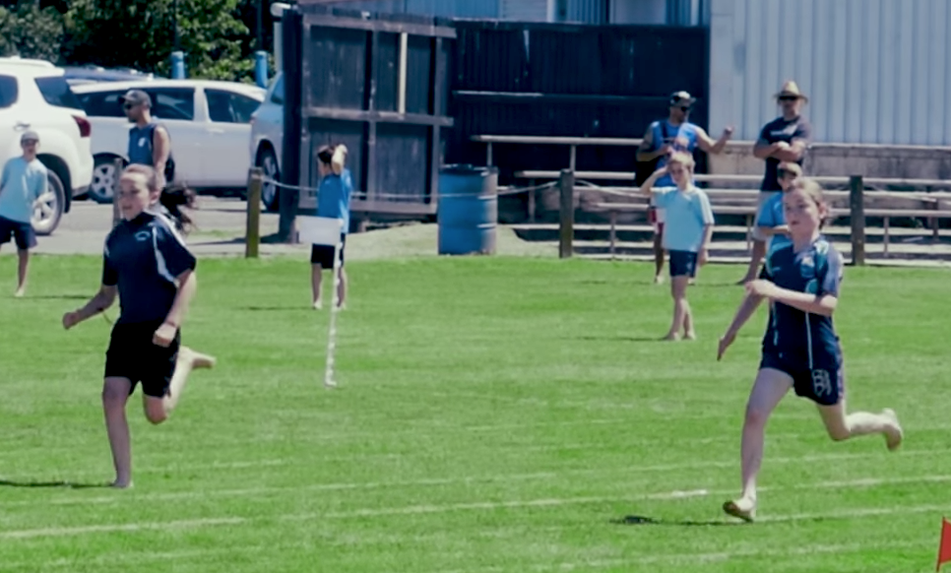
A Story from Room 1
– by Ryan Jope.
Once upon a time there was a goose and she wanted to make a chocolate banana cake. The goose said “Can the dog get me some milk?” “Yes! I can get some milk.” The goose asked the goat to get some flour. “I will get some flour,” said the Goat. “Can you get some chocolate for me?” “No! I will not get the chocolate because I’m busy.
So the Goose got the chocolate herself. The cake was ready to eat…the cat didn’t get any because he didn’t help! Then the other animals ate it!!!

A Story from Room 3 – By Isabella Lanceley.
Once upon a time there was a little poor village and they had a big problem. There were two dragons behind that village but the youngest dragon was slayed so it was all up to that one dragon to fight a whole village.
One day the dragon came roaring out from behind the village and caught a house on fire.
What will they do next?

FROM ROOM 2 - By Lucy Didsbury
Tramping is awesome! You get to see trees, flowers, rivers and loads more! You also get loads of fitness. If you like those things you’ll have to go tramping.
Farming is also outdoorsy. Sometimes you farm plants like peas, apples, and corn. Other farms farm cows and sheep for meat. Some farms do both.
When you swim you can splash around and have fun, or you can do strokes for exercise. There four strokes and they are all pretty simple. After swimming you often feel hungry from all the exercise.
Sport is exercise, fun, and often teamwork. There are many types of sport and all are fun. Sport is awesome!
Why would you even want to be fit? Well, the choice is either fit or fat. I would rather be fit. Also, being fit helps your heart beat stronger. When your heart beats it is pumping the blood around your body. If your heart stops you will die because the blood can’t get around you. When you exercise your heart has to beat faster.

WEEK 4 LEARNING AWARDS

PRINCIPAL’S AWARD: CAEDEN LENIHAN -
For following the Pirinoa Path by being active with a positive attitude – you are always smiling and jumping around having fun!

ROOM 2: ALEC MCDOWALL – For an awesome effort during athletics day.

ROOM 3: ISABELLA LANCELEY - For an awesome effort during athletics day.

ROOM 1: MELESIA ENE – For showing independence when doing classroom activities.

YEAR 8 PLAYGROUND AWARD: CAEDEN LENIHAN – For behaving well in the playground and looking after others.
SCHOOL WEBSITE: If you ever need any information, or cannot find our school newsletter, go to our school website: www.pirinoa.school.nz On there you will also find events coming up on the school community calendar. Check it out!

ROOM 2 NEWS

