Pirinoa School ~Vibrant and Successful learning
Te kakama, te momoho o te ako

Newsletter ~ 17th June 2016 Week 7 Term 2
Principal ~ Troy Anderson Tel: 063077829 Fax: 063077510
Email: office@pirinoa.school.nz
Kia Ora Koutou

It was exciting to hear about the success that our students achieved at the cross country on Wednesday. I was super proud of all that participated and the great placings of all and because of this the year 3-8 students that are going through to the Interschool on Wednesday the 22nd of June are: Jayden Hume, Jack McDowall, Marshall Love, Alec McDowall, Kingston Love, Jono Didsbury, Te Atawhai Love, Shakia Baird, Charlotte Jephson, Polly Telford, Kala Baird, Leah Hume, Charlie Kerrison-Jones, Maralyse Whiteman, Amanda Jephson, Maddie Kerrison-Jones, Olivia Telford, Aria Whiteman, Aleesha Hume and Lucy Didsbury. There will be an attached permission slip for these students, if you could have it back by Monday please.

As you may well know we had our ERO review last week, they were here for 3 days auditing everything we do. It was a great process to go through and some excellent learning took place. They were very impressed with the teaching and learning that is taking place at Pirinoa School and the path that the school is on, so that is very pleasing.

I have put on the Pirinoa School Facebook page about if your child is sick i.e. vomiting or diarrhea they need to be away from school for 48hrs from the last time they vomited or had diarrhea. It seems to be going around and if we all could adhere to this it would be greatly appreciated. Just remember it is up to you to contact the school if they are absent from school, thanks in advance.

If anyone has photos of children participating in activities that is awesome and please share so we can upload them, however it is important to get permission from me and the parents of that child/ren. It would be appreciated as some people don't want pictures of their child floating around on the internet.
Your Principal
Troy Anderson

 | JUNE
5 |  | Queens B’day 6  School closed | ERO Visit 7 | 8 | 9 | X-country 10  @ Kahutara | 11
12 |  | 13 | 14 | 15 | 16 | 17 | 18
19 |  | 20 | 21 | I/school 22  X-country | 23 | 24 | 25
26 |  | 27 | 28 | Rotary Y7/8 speech comps 29 | 30 | JULY 1 | 2
 | JULY
3 |  | 4 | 5 | 6 | 7 | End of T2 8 | SCHOOL 9  HOLIDAYS
10 |  | 11 | 12 | 13 | 14 | 15 | 16

Did you know?
- ASSEMBLY: Every Friday at 12.10pm followed by sausage sizzle.
- SAUSAGE SIZZLE: Thank you to ANDREA DIDSBURY who is cooking on 24th June.
- SCHOOL INVOICES: Whilst parent donations are voluntary, fees such as stationery, technology (Yr 7 & 8), any outstanding sausage sizzle items, etc. are payable. Thank you to those who have made payments. If you wish to pay by instalments that’s perfectly ok and we appreciate it.
- SCHOOL NOTICEBOARD: Don’t forget to check out our school noticeboard…lots of events happening around our area, especially fun school holiday programmes in Martinborough.
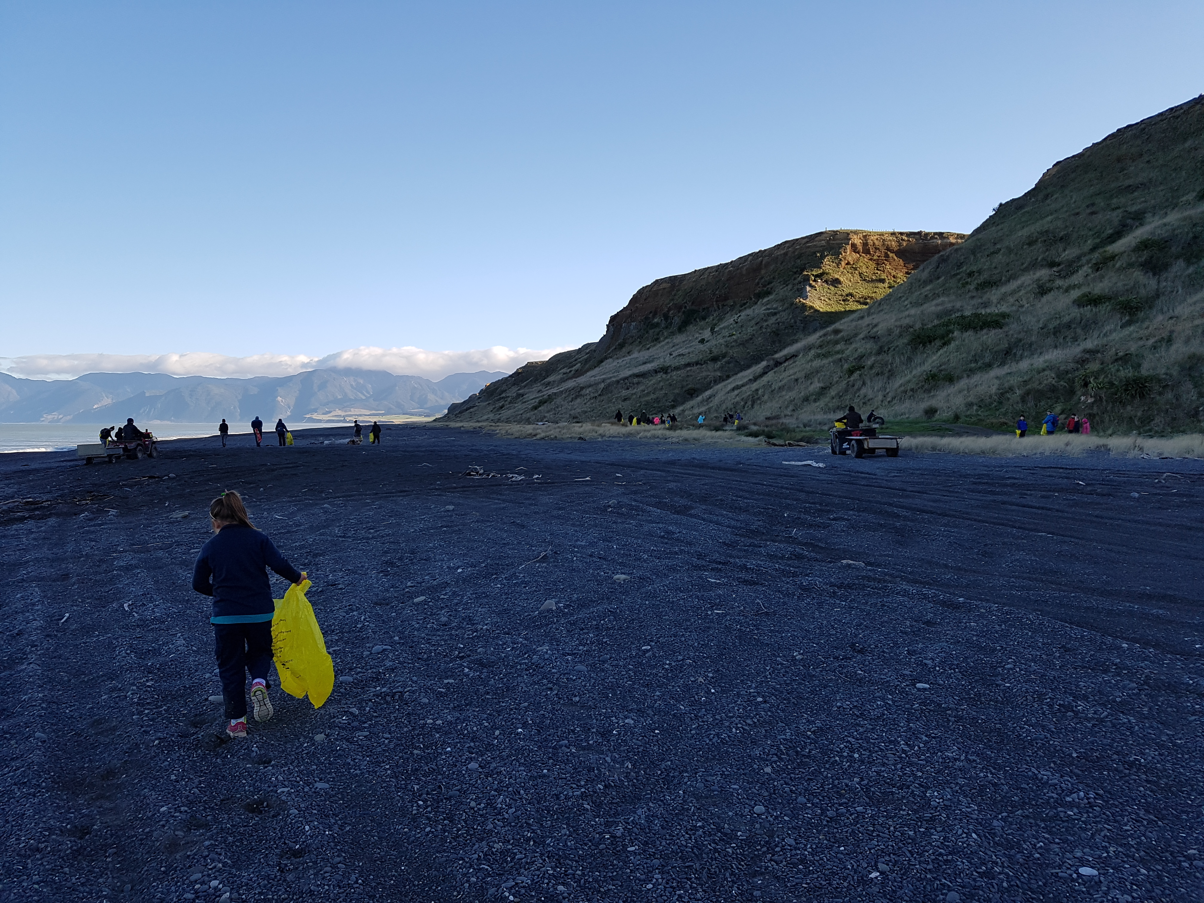
LAKE FERRY BEACH CLEANUP
HOCKEY RESULTS:
Pirinoa Strikers: Loss. Player of the day: Shakia.
HOCKEY DRAW:
Monday 20 June –v- Kahutara @ 6pm THT Oranges: Marshall.
Monday 27 June –v- Kia Kaha @ 5pm THT Oranges: Olivia.

RUGBY RESULTS:
U6: Win
U9: Win
U11: Loss
U13: Win.

RUGBY DRAW – Saturday 18th June.
U6 @ 9.30am vs Gladstone Gold @ Greytown F12; 10am vs Gladstone Black Greytown F12.
U8 @ 9.30am vs MRS @ MRS Field 21;
10am: BYE.
U9 @ 9.30am vs Marist Green @ Marist F1b.
U 11 @ 10.30 vs Marist @ Marist F2.
U13 @ 10.30am vs MRS White @ MRS F1.

NETBALL RESULTS:
Stars: Loss
Swans: Win
Steel: Bye last week.

NETBALL DRAW: Saturday 18th June:
All games at Kuranui.
Steel –v- Lakeview Opals @ 9am Ct 4
Stars –v- St Pats Hearts @ 10am Ct 5
Swans –v- Solway Rubies @ 11am Ct 3.
ROOM 2 NEWS
This week was a different week than normal because on Wednesday we had cross country and everyone in this School did AMAZINGLY well. Everyone was tired though. On Monday Pirinoa Strikers played Martinborough 1st 11 and they lost 7-0. In that game Kala got hit by the ball and she now has a big bruise on her leg. The new girls Charlie and Maddie are fitting in really well. Tuesday we had tuakana/teina and we had to teach the Room 1s how to do slide show. It was so cute. Friday is the most best day and it is BEACH CLEAN UP!! WHOOT WHOOT!
By Charley Jephson.

ROOM 1 WEEKLY NEWS.
We had a great day at Cross-Country. The children ran really well and tried their best. Congratulations to Aria, Aleesha, Lucy and Alec who will be going to the South Wairarapa Cross-Country next Wednesday.
In class we have been doing art around the world and this week we are looking at New Zealand. We are making Koru pictures and learning how to blend colours.

YUMMY APPLES School sticker promotion on now…collect individual Yummy stickers and/or cut-out labels from apple bags and bring into school…earn double points by using the New Variety Sticker Collection Sheet (available from www.yummyfruit.co.nz).
If Lynette isn’t in office, please pop your stickers or labels into the yellow ASB box. This is a great way for our school to get free sports equipment, so your support is appreciated.
BOARD OF TRUSTEES ELECTION 2016
We welcome Natalie Love and Andrea Didsbury to the Board of Trustees, along with returning trustees, Stu Weatherstone, Tamara Williams and Kim Whiteman.
Thank you to everyone who took the opportunity to send in their vote…of 43 papers sent out we received 34 back, which is a pretty good percentage!!

