Pirinoa School ~Vibrant and Successful learning
Te kakama, te momoho o te ako

Newsletter ~ 2nd February 2018 Week 1 Term 1
Principal ~ Matt Jackett Tel: 063077829
Email: office@pirinoa.school.nz
Tēnā koutou katoa
Welcome back everyone to another year full of fun, learning, and friendships!
It was fantastic to see excited students on Wednesday morning, who were keen and ready to learn. Our three new students have enjoyed their first three days at Pirinoa School. A warm welcome to Beauden, Hazel and Shayla. We have also formally welcomed Natalie Lagah onto our staff. Ms Lagah will be teaching the Year 3 and 4 students in Room 2 (which is the old library).
We have had three full and eventful teacher only days already this year, looking at our Strategic Plan and how we can maximise the learning for our students. Please ask your child/children what they are excited about at school, and encourage them to take all of the opportunities that are available to them this year.
We were lucky to have parents, students, and teachers all turn up to the working bee over the holidays. It is very motivating to all of our staff and students at Pirinoa School, to know that we have a community that supports us. Thanks again everyone! Feel free to come and check our new revamped classroom and school pet Toby and our new goldfish.
National Standards have been removed this year. A new progressed based approach will be developed in collaboration with all education stakeholders. I will keep you informed on the progress with this. Basically, it’s business as usual at Pirinoa School with less reporting to the Ministry of Education. We will always be aiming to meet the learning and well-being needs of all students, regardless of whether National Standards exist or not.
The Rotary Club have been generous once again, and every year 6 student has a brand-new dictionary to take home and use. The Rotary Club also give a new book to all new entrant students at Pirinoa School.
We wish our cleaner Amanda and her daughter Bella all the best for their journey ahead. A wise man once said to me “The only thing that is permanent is change”. Thanks Amanda for all of the hard work you have put into Pirinoa School. We now have a new cleaner named Shannon Payne joining us. Please introduce yourself and make her feel at home if you see her at school.
Have a great weekend and a good break if you’re heading away for Waitangi Day.

A few reminders
Please check that your child has:
A hat to wear every day at school;
Their swimming gear;
Their stationery;
You have read, signed and returned all permission slips the day after they are handed out.

Events coming up
Round the bays – an optional run in Wellington that has a price attached – unfortunately it’s on the same day as the Ngawi Big Three.
Ngā mihi,
Matt Jackett

 | FEBRUARY
MONDAY |  | TUESDAY | WEDNESDAY | THURSDAY | FRIDAY | SATURDAY | SUNDAY
 |  |  | Term 1 31 | 1 | 2 | 3 | 4
5 |  | WAITANGI 6  DAY | 7 | 8 | 9 | 10 | 11
12 |  | 13 | Rocky 14  Shore visit | 15 | Yr7/8 16  cricket | 17 | Round the 18  Bays
19 |  | 20 | 21 | 22 | 23 | 24 | 25
26 |  | Cluster 27 swimming  sports | 28

Did you know:
- SAUSAGE SIZZLE: Orders for sausage sizzles are taken at 9am every Friday morning. Please ensure your child has their money with them so we can take their order. Many thanks.
- SCHOLASTIC BOOK CLUB: If you wish to purchase anything from Scholastic Book Club please ensure your order, together with payment reaches school office no later than Monday 12th February. For every book purchased our school will receive rewards enabling us to purchase books for our school library.

ROOM 3 NEWS
I hope everybody had a great holiday.
In Room 3 this Term we are looking at what makes us unique and our oceans. The students have written their swimming goals and we are hoping to go to the Martinborough pools to practise endurance, block diving and survival skills.
Homework will be given out on Tuesday and completed by the following Monday. This will mainly consist of spelling, basic facts and topic work.
I've had a wonderful couple of days teaching Room 3 and I am so impressed with their positive attitude and enthusiasm towards learning and school.
Sissy Pickering – Year 5 to 8 teacher.

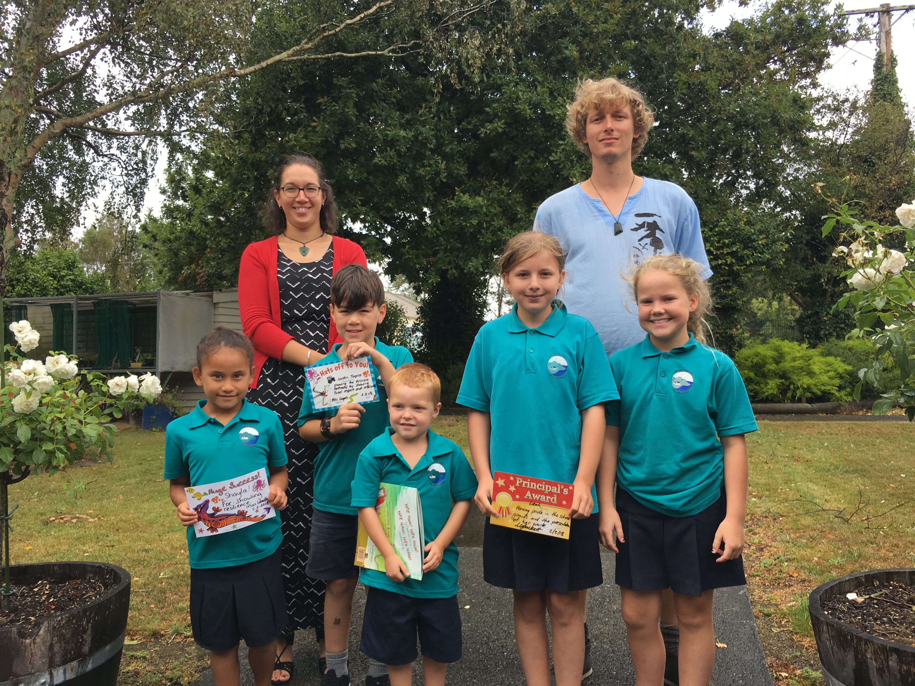
ROOM 1 NEWS
Dear parents and whanau,
I hope everyone is fresh and ready to start 2018 with a splash at school and the holidays have treated you well. I’m excited to be teaching in Room 1 this year with the new entrants, year ones and twos. Our topic for the whole school is the ocean. We will be using an inquiry based approach. This is great way to get students engaged, asking questions, thinking and contributing. Come in and see what we are doing anytime or email: tara.woodhouse@pirinoa.school.nz with any questions. If students have any shells, seaweed or drift wood, in fact anything interesting from the sea or about the sea, please feel free to bring it along to school. It will be looked after. I am also using a play based approach for Room 1 alongside Literacy and Numeracy, to bridge the transition from playgroup to school. There is are construction, play dough, water, arts and crafts, writing and maths areas for students to explore. Regards, Tara Woodhouse Year 1 & 2 teacher.

SAUSAGE SIZZLE: As we have a few new families here is some information on our sausage sizzle. Students may purchase a sausage on bread for $2 each. Funds raised go towards student resources. We do ask that every family take a turn at cooking the sausage sizzle and a roster is attached to this newsletter. Please fill in the day which suits you and once I have received them back I will draw up a roster and advise you. Thank you for your help.

ROOM 2 NEWS
We have had a busy week in Room 2, getting to know each other and getting to know our new class pet, a turtle called Toby.
This term we are going to explore a range of topics, including ‘Ocean Life’ and ‘Farm Life’. Our main goal for this term is to make sure all of our learning is exciting and interesting, as well as build strong relationships with each other and our new classroom environment.
Feel free to pop in before or after school to see what we have been learning about.
Natalie Lagah – Year 3 & 4 teacher.
Ms Lagah and Mr Schaller with our student award recipients.
WEEK 1 LEARNING AWARDS
PRINCIPAL’S AWARD: LEAH HUME -
For having pride in the school grounds and the presentation of her work

ROOM 2: JAIDEN TIOPIRA - for "Total Respect and Resilience".

ROOM 1: SHAYLA TAUI - for showing resilience. She has settled into the routines in Room 1 confidently. Well done, Shayla!

ROOM 3: CHARLIE KERRISON-JONES and LEAH HUME - for being great senior role models at Pirinoa School.

PLAYGROUND AWARD: BEAUDEN PORTAS – For great swimming.
ROOM 2 NEWS

