Pirinoa School ~Vibrant and Successful learning
Te kakama, te momoho o te ako

Newsletter ~ 16th February 2018 Week 3 Term 1
Principal ~ Matt Jackett Tel: 063077829
Email: office@pirinoa.school.nz
Tēnā koutou katoa

A school vision is a one line statement that is our preferred destination for all of our students.
After many fruitful discussions with the community, parents, students, and the School Board, we now have our new Pirinoa School vision, which is:

Inspired, Confident, Proud Tamariki

A school mission is often wordier and explains how an organisation aims to get to their destination.
Pirinoa School’s new mission is:

Pirinoa School is the heart of our community. We come together to create a variety of opportunities, that help all students excel as learners and members of society.

I hope you can all relate to and believe in the above two statements, as we now need to work together in order to achieve the best possible outcomes for all students.

I want our students to be inspired by the people they meet and work with at school; confident to take on new opportunities and challenges; and proud of what they have achieved in the time that they have with us. Tamariki means children. Children are at the heart of all our decision making and actions.

Week 3 has been a great week. We have had our first board meeting, fire drill, trip out of school, and I have been to a sports meeting, South Wairarapa Principals meeting, and Community of Learning meeting.
A big thanks goes out to Ms Pickering for organising an exciting day out to Ngawi packed with activities. We can learn lots in a classroom, however nothing will ever beat a real-life experience. We were also very lucky to have so many supportive parents who are able to transport us to and from each venue. Parents, we can’t do these fun trips without you. One of my highlights was seeing the many Orca/Killer Whales just off the coast, thanks to Wayne’s excellent spotting.

All the best to those who will be fishing and enjoying the festivities in Ngawi over the weekend.
Also, good luck to the 12 students, 3 teachers, and 2 parents from Pirinoa, who will be running the 6.5km Round the Bays run in Wellington.

Ngā mihi, Matt Jackett

 | FEBRUARY
MONDAY |  | TUESDAY | WEDNESDAY | THURSDAY | FRIDAY | SATURDAY | SUNDAY
12 |  | 13 | Rocky 14  Shore visit | 15 | Yr7/8 16  cricket | 17 | Round the 18  Bays
19 |  | 20 | 21 | 22 | 23 | 24 | 25
26 |  | Cluster 27 swimming  sports | 28
 | MARCH
MONDAY |  | TUESDAY | WEDNESDAY | THURSDAY | FRIDAY | SATURDAY | SUNDAY
 |  |  |  | 1 | Ki o Rahi 2  Year 7/8 | 3 | 4
5 |  | 6 | I/school 7  Swimming | 8 | 9 | 10 | 11
12 |  | Technology 13  Y7/8 | Wai. Swim 14  Champs | 15 | 16 | 17 | 18

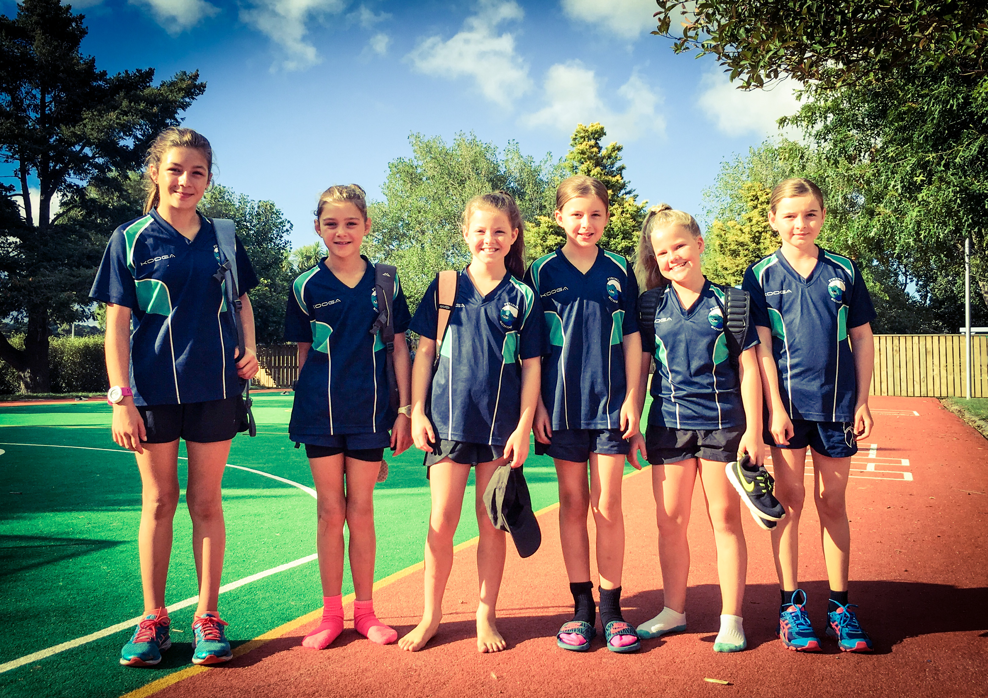
ROOM 3 NEWS
We had a great trip to Ngawi on Wednesday. The weather was perfect and even a pod of orca came to visit us. Thanks to all the parents and caregivers that provided transport. It was great to see all the adults sharing their knowledge with the children about the rocky shore. We discovered lots of creatures that live in a tidal pool environment. We saw sea snails, crabs, fish and starfish. Next week we will be writing action questions and investigating possible answers to these questions.

VOTE FOR US!!
Come on, vote for our school…the more votes we get the more chances we have of winning some science equipment for Pirinoa School.
You can vote for us here: http://www.schoolgen.co.nz/voteforyourschool/
Remember, you can vote once a day up until voting ends on 2 April. The size of our school doesn’t matter as votes are divided by the school roll to make it fair.

ROOM 1 NEWS – By Vienna Weatherstone.

To get into their homes they get the sand and bring it out. Yellow ants eat crabs. Some crabs walk forwards and crabs eat fish.

ROOM 2 NEWS – By Matai Andersen.
Yesterday we went to the rocky shore.
First we went to the rocky shore…We saw the rocks and the water.
Then we went to the seals. The seals were barking.
Then we went to the lighthouse. I climbed up the steps to the top.
Lastly, we went to the wash pool. I saw whales.
My favourite part was swimming
Students searching for the killer whales.
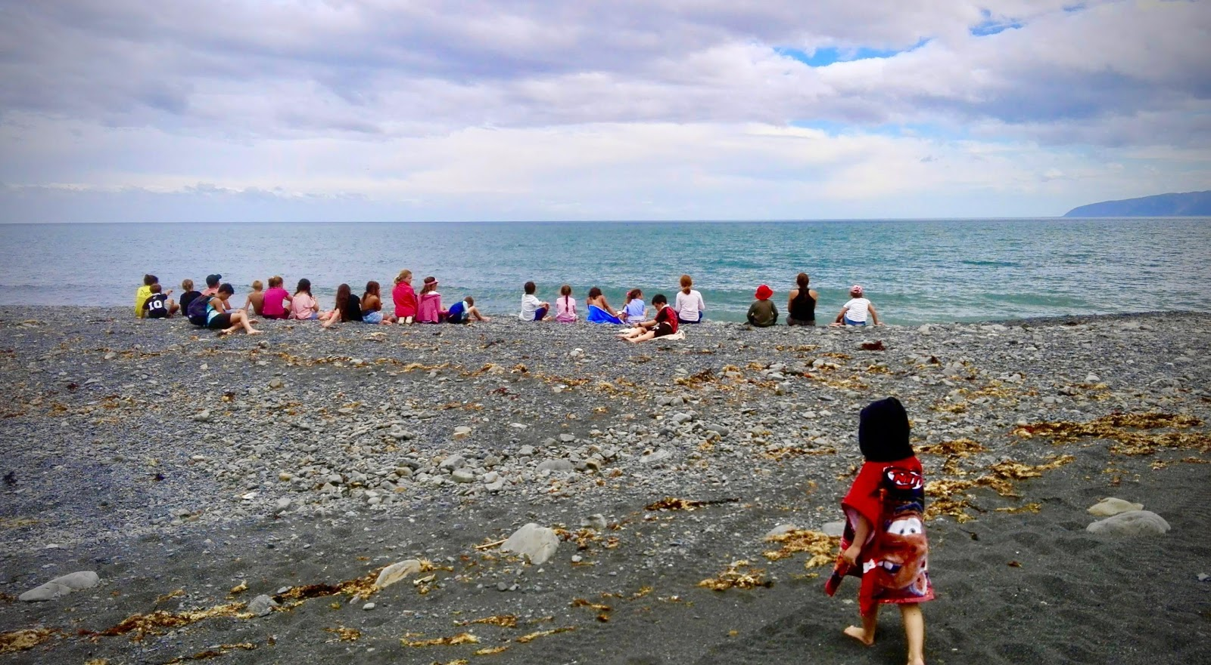
Did you know:
- SAUSAGE SIZZLE: Please find attached the completed sausage sizzle.
Many thanks.
- SWIMMING: Swimming is part of the Term One curriculum so please ensure your child bring their togs and towel every day. Thank you.

WEEK 3 LEARNING AWARDS

PRINCIPAL’S AWARD: CARTER LOVE -
For Being Active with a Positive Attitude
By walking up to the top of the lighthouse.

ROOM 2: KASSIE BOYLE - for taking pride in her learning / classroom.

ROOM 1: MELESIA ENE - for following the Pirinoa Path. She always shows respect to others and is well prepared for learning every day with a great positive attitude!

ROOM 3: NAKCHA ROBINSON – For being active with a positive attitude.

PLAYGROUND AWARD: GARNIER BRAGGER – For always finishing her work on time and being on task.
ROOM 2 NEWS

