Pirinoa School ~ Vibrant and Successful learning
Te kakama, te momoho o te ako

Newsletter ~ 2nd March 2018 Week 5 Term 1
Principal ~ Matt Jackett Tel: 063077829
Email: office@pirinoa.school.nz
Tēnā koutou katoa
Another busy and positive two weeks at Pirinoa School. Thanks everyone for supporting Charlie and Leah with their triathlon last Friday. It was a great day and a fantastic illustration of what we are trying to achieve at Pirinoa School, with students taking the lead with their learning. As Charlie and Leah found out, an event that seems relatively simple, requires a lot of work to happen behind the scenes. It was good to see our local Mayor Viv Napier join us for the day. Similar to Robert Muldoon back in 1981, I’m not the biggest fan of mixing sport and politics, however the water situation was mentioned to the mayor.

Later that day we took our confident swimmers to the Martinborough Pool for a final training before this week’s swimming sports. We also covered water safety activities as the pool is a lot deeper ours. Thanks to all of the parents who helped out with transport.

This Tuesday I was very impressed with the students who took part in the swimming sports. Although a coldish day, our swimmers showed determination in the water and excellent behaviour. Once again, it was great to have so much support from our parents. The next round of swimming is next week.

In classroom news, Room 1 had a new teacher on Monday for the day. I was well due to teach the juniors and had a great time doing so. With only 13 students to teach, I had lots of time to listen to everyone’s stories about the weekend and give individual support. I also read one of my all-time favourite stories “I’m the king of the mountain”, and had a dance off with Vincent (which he easily won).

Lastly, thank you for sharing positive comments with myself and your child’s teacher about how the year has started for your children. I think things have gone very well so far, and look forward to helping all students progress throughout the year. I hope you all have a great weekend.

Ngā mihi, Matt Jackett

 | MARCH
MONDAY |  | TUESDAY | WEDNESDAY | THURSDAY | FRIDAY | SATURDAY | SUNDAY
5 |  | 6 | I/school 7  Swimming | 8 | 9 | 10 | 11
12 |  | Technology 13  Yr 7/8 | Wai. Swim 14  Champs | 15 | 16 | 17 | Round the 18  Vines
19 |  | Technology 20  Yr 7/8 | 21 | 22 | 23 | 24 | 25
26 |  | Technology 27  Yr 7/8 | 28 | 29 | Good Friday30  School closed | 31
 | APRIL
 |  |  |  |  |  |  | 1
Easter Monday 2  School Closed |  | Easter Tues. 3  School closed | Back to 4  school | 5 | 6 | 7 | 8
9 |  | Technology 10  Yr 7/8 | Technology 11  Yr 7/8 | 12 | End of T1 13 | HOLIDAYS 14 | 15

ROOM 3 NEWS
Congratulations to all the swimmers that took part in the cluster swimming sports in Featherston. We have completed a classroom census last week and our next task is to analyse the results and present our findings to the class and school. In writing, we have been publishing reports about sea creatures and learning how to paragraph our ideas and write introductions and conclusions. Next week the students will be participating in a bike safety/skills course at school. Homework is due on Monday.

ROOM 1 NEWS – By Skye.
I like penguins because they waddle and there are heaps of different types of penguins. I know one type of penguin, the blue penguin.

VOTE FOR US!!
Come on, vote for our school…the more votes we get the more chances we have of winning some science equipment for Pirinoa School.
You can vote for us here: http://www.schoolgen.co.nz/voteforyourschool/
Remember, you can vote once a day up until voting ends on 2 April. The size of our school doesn’t matter as votes are divided by the school roll to make it fair.

TUHIRANGI JAB RUGBY - Registration and weigh in will be held on Thursday 8th March 2018 at 3.30pm at the Pirinoa Hall. All new and existing players are welcome. The registration and weigh in will cover the following grades: U6 Rippa, U8, U9, U10, U11 and U13. It would be appreciated if subs of $30 could be paid on the day. Any questions please contact Malcolm Jaspers on 3069896.
Our students hard at work on Enviro Schools.
ROOM 2 NEWS – By Isabella.
This week Room 2 have been learning about sea turtles.
I learnt about a Green Sea Turtle. Green sea turtles live in the Galapagos Islands. They can live for 80 years. They eat lots of jellyfish. We shouldn't dump plastic bags on the beach because the turtles eat them and die. Green sea turtles have a great brown shell and are a type of reptile. They have been around for 100 million years.

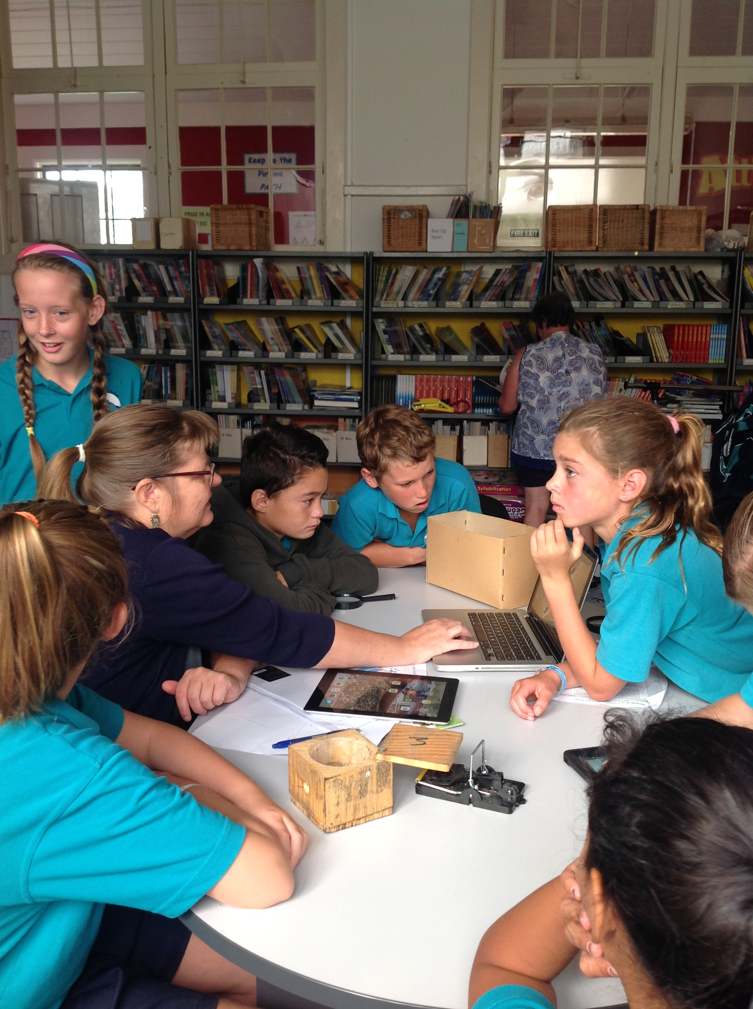
MESSAGE FROM THE BOARD CHAIR.
The school year is well underway now. There is a great vibe at the school. Starting the year with a full complement of staff is great. Having the three full time classes reducing the students per teacher creates a great opportunity for our children.
The board would like to thank Kim Whiteman for her outstanding contribution to the school as a board member. Kim resigned as a parent trustee before the new school year.
Kim was exceptional as a trustee and had a positive impact on all aspects of the school. Thank you
Be proud !

Did you know:
- SAUSAGE SIZZLE: By purchasing a sausage sizzle on Fridays you are supporting our school’s fundraising…thank you.
- PEDAL READY – Cycle skills for Rooms 2 and 3. Please complete form and return to school by Monday.
- INTERSCHOOL SWIMMING: Wednesday 7th March. Permission forms sent home today to qualifying students.

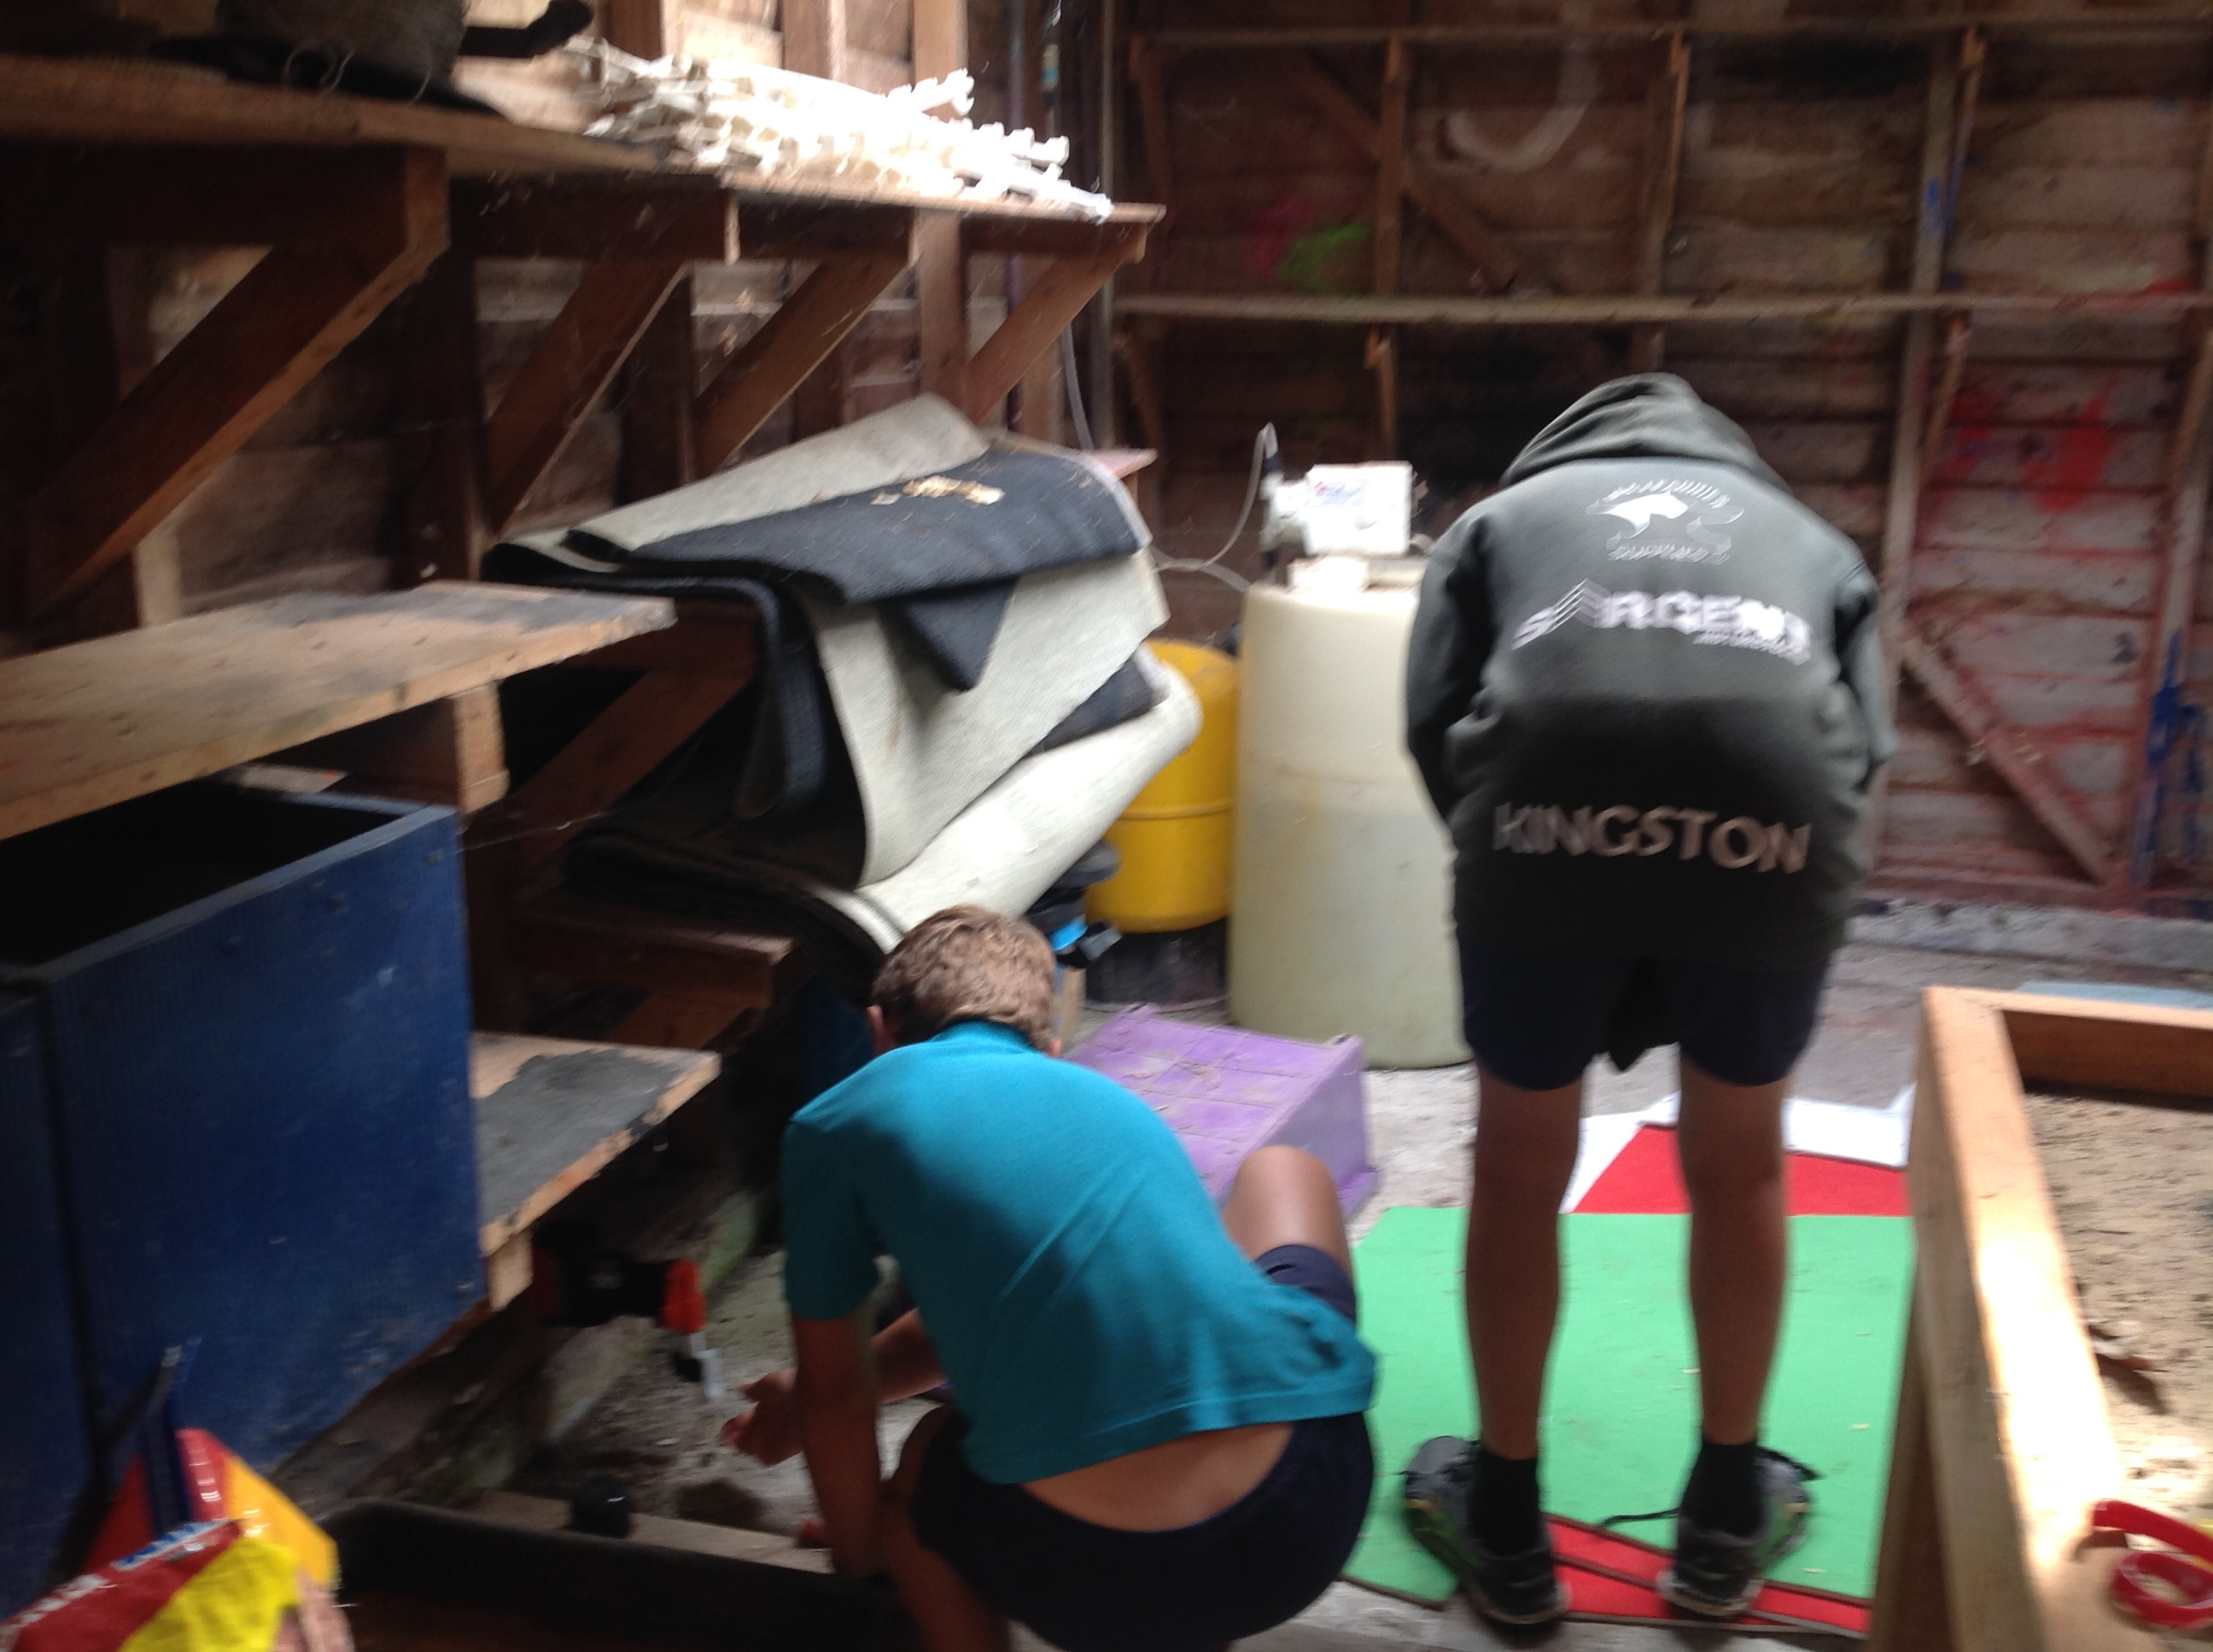
WEEK 5 LEARNING AWARDS

PRINCIPAL’S AWARD: SKYE MACDONALD - For following the Pirinoa Path by showing total respect and resilience.

ROOM 2: WILLOW MACDONALD - For always showing respect and using her manners.

ROOM 1: VINCENT EDGE - For following the Pirinoa Path. He completed the school solo triathlon!

ROOM 3: AMANDA JEPHSON and EDWARD WEATHERSTONE – For showing leadership skills in the pool.

ROOM 2 NEWS

