Pirinoa School ~ Vibrant and Successful learning
Te kakama, te momoho o te ako

Newsletter ~ 16th March 2018 Week 7 Term 1
Principal ~ Matt Jackett Tel: 063077829
Email: office@pirinoa.school.nz
Tēnā koutou katoa
Who has checked the Pirinoa School website recently? If not, have a look tonight. Mr Schaller, the students, and the teachers have been working together to create a fresh look for the website. I think it looks fantastic, but we are not finished yet! Thanks for returning the computer forms back to the school. We want to use computers at the school in meaningful ways to support student learning, and to communicate what is happening with the parents and community.

Last Tuesday we had two specialist bike coaches from Pedal Ready, working in the senior room. They were so impressed with the learning and attitudes in the senior room, they offered to take the class to the next level. This course is in Martinborough and will hopefully happen before the end of the year. They will also be returning to teach the year 3 and 4 class this year.

We have had several students represent Pirinoa School in the Martinborough School ‘Try’athlon over the last two Fridays. I was very proud of the students who put their hand up and took the opportunity to compete in these events. Thanks to the parents who helped out with transport and supported our students.

On Wednesday evening, we had the final swimming sports competition. Although our students found it challenging, they all did themselves and the school proud. Edward and Amanda were the standouts, and both came second in their freestyle events.

Getting tired of making school lunches on a Friday? Please support our school by purchasing the tastiest sausages and beef patties in the Wellington Region. They are only $2 and come with bread and tomato sauce.
Have a great weekend.
Matt Jackett

 | MARCH
MONDAY |  | TUESDAY | WEDNESDAY | THURSDAY | FRIDAY | SATURDAY | SUNDAY
12 |  | Technology 13  Yr 7/8 | Wai. Swim 14  Champs | 15 | 16 | 17 | Round the 18  Vines
19 |  | Technology 20  Yr 7/8 | 21 | 22 | 23 | 24 | 25
26 |  | Technology 27  Yr 7/8  TouchRugby | Take a Kid 28  Fishing | 29 | Good Friday30  School closed | 31
 | APRIL
 |  |  |  |  |  |  | 1
Easter Monday 2  School Closed |  | Easter Tues. 3  School closed | Hockey Y7/8 4 | Bat & 5  Baseball | 6 | 7 | 8
9 |  | Technology 10  Yr 7/8 | Technology 11  Yr 7/8  School bbq. | 12 | End of T1 13 | HOLIDAYS 14 | 15

ROOM 1 NEWS – By Jacob Manze.

Lobsters are crustaceans and they also have exoskeletons.

ROOM 3 NEWS
This week the Year 7 and 8’s had their first Technology day for the Term. They are learning to sew. While the Year 7’s and 8’s were at Technology the Year 5 and 6’s did Technology at school. We weeded out the strawberry patch and barked it, we bottled “worm wine” all ready to sell and re-labelled it. We also did some cooking. We made lolly cake and toasty sandwiches.

RICHIE’S MILK RUN
Have you all seen the flyer delivered in the mail this week. All you need to do is fill in the entry form and tell them why you think Richie should land at Pirinoa School. Add a photo/video with your entry too if you like.
Nominate our school so we are in to win.
See attached flyer.
YEAR 7/8 TECHNOLOGY FEES
Year 7/8 Tech fees of $57.50 are now due.
Pirinoa School pays 50% of the cost and the remaining 50% is a compulsory fee to be paid by the student please.
If you wish to pay in instalments please see Lynette in office. Thank you.

ROOM 2 NEWS – By Ursula, Willow & Kassie.
Last week on Discovery Friday, we were learning about the bones in our body. We had to put stickers on our bodies to label where the different bones were. Then we had to build a skeleton which we hung on the wall. At the end of the day we got to label the bones using Miss Lagah as our model, with the stickers we used earlier in the day.

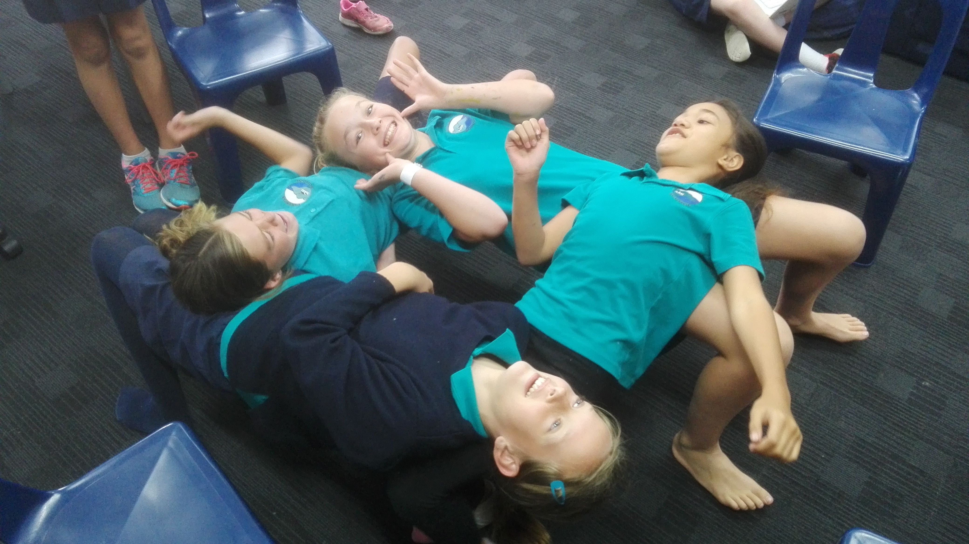
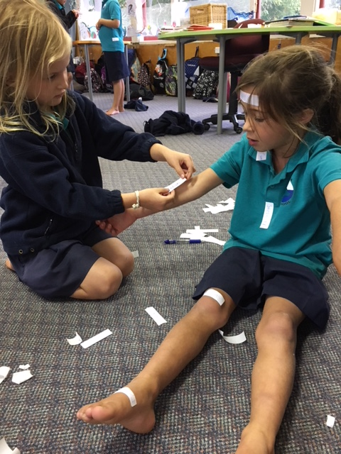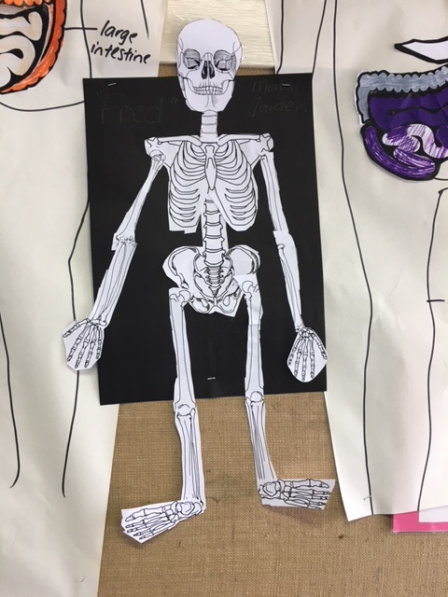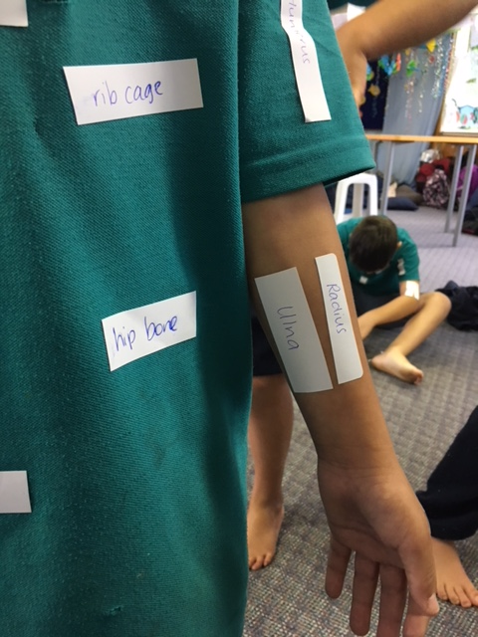
VOTE FOR US!!
Come on, vote for our school…the more votes we get the more chances we have of winning some science equipment for Pirinoa School.
You can vote for us here: http://www.schoolgen.co.nz/voteforyourschool/
Remember, you can vote once a day up until voting ends on 2 April. The size of our school doesn’t matter as votes are divided by the school roll to make it fair.

Events coming up
Fishing trip
Hockey year 7/8
Touch Rugby
Bat and Ball Baseball
End of term BBQ – Wednesday 11th April at 5.30pm.

WEEK 7 LEARNING AWARDS

PRINCIPAL’S AWARD: INDY WILLIAMS -
For showing excellent leadership skills during filming by motivating her team

ROOM 2: URSULA WHITEMAN - for trying hard to complete all of her work to a high standard.

ROOM 1: JESSEY HEDGECOCK - For making a huge effort in his spelling!

ROOM 3: OLIVIA TELFORD – For helping others.

PLAYGROUND AWARD: EDWARD WEATHERSTONE – For being kind and following the Pirinoa Path.
ROOM 2 NEWS

