Pirinoa School ~ Inspired, Confident, Proud Tamariki

Newsletter ~ 6th April 2018 Week 10 Term 1
Principal ~ Matt Jackett Tel: 063077829
Email: office@pirinoa.school.nz
Tēnā koutou katoa
With only one week to go, there are many tired faces (including myself) around Pirinoa School. I hope you all had a fantastic Easter break and are ready for one more week of focussed learning!

This term Pirinoa School has focussed on ‘Our Moana’ where we learnt about the sea, building our classroom culture while focussing on the Pirinoa Path, and being physically active by organising and participating in a variety of sports.

I have been very impressed with the support our parents have given the school this term. Lots of schools struggle to enter events due to the lack of parent support whether it be coaching or transport. However, this has never been an issue yet for our school. A big thanks goes out to Sonya, Carolyn, and Kim and Owen for their work with the school pool. There are a lot of other parents who do work behind the scenes and I thank you all for this.

We have added some new assessments this year for the year 3 and older students. This is to ensure we have valid and reliable assessment information. We will also be able to create clearer goals for every student that are based on these assessments. Next term a goal setting sheet will be given out during week 1. We also have our midyear reports coming out later in the term, which are followed by parent teacher interviews.

I hope to see you all at our farewell BBQ next Wednesday at 5.30pm. We want to wish Lynette all the best for her future as she has done an excellent job at Pirinoa School over the years. It will also be great to give a warm Pirinoa welcome to our new teacher, ICT teacher, and office administrator.
Inspired, Confident, Proud Tamariki

Matt Jackett

 | APRIL
MONDAY |  | TUESDAY | WEDNESDAY | THURSDAY | FRIDAY | SATURDAY | SUNDAY
9 |  | Yr7/8 Tech 10 | Yr 7/8 Tech 11  School BBQ  5.30pm | 12 | End of T1. 13 | HOLIDAYS 14 | 15
16 |  | 17 | 18 | 19 | 20 | 21 | 22
23 |  | 24 | ANZAC DAY 25 | 26 | 27 | 28 | 29
START OF 30
TERM 2
 | MAY
 |  | 1 | 2 | 3 | 4 | 5 | 6
7 |  | 8 | 9 | Take a kid 10  Fishing | 11 | 12 | 13
14 |  | 15 | 16 | 17 | 18 | 19 | 20

Our students have been super busy out and about taking part in sporting activities…Thanks Sonya for the great photos!
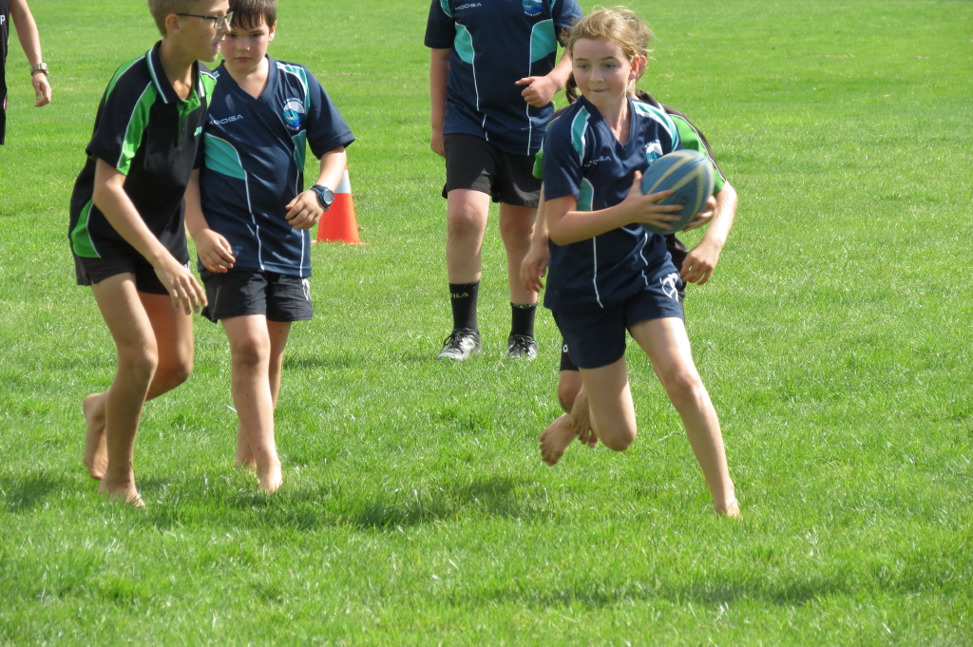
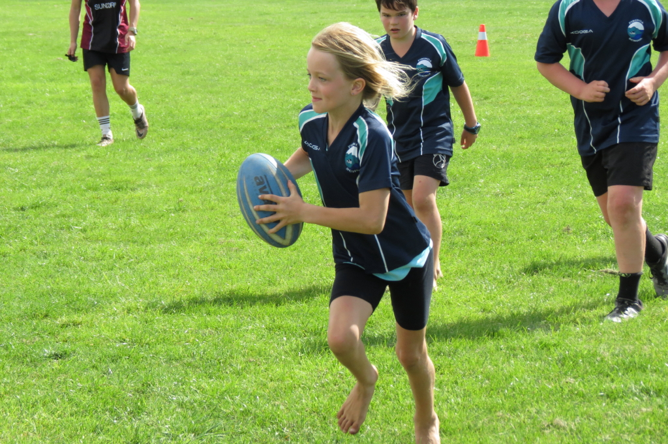
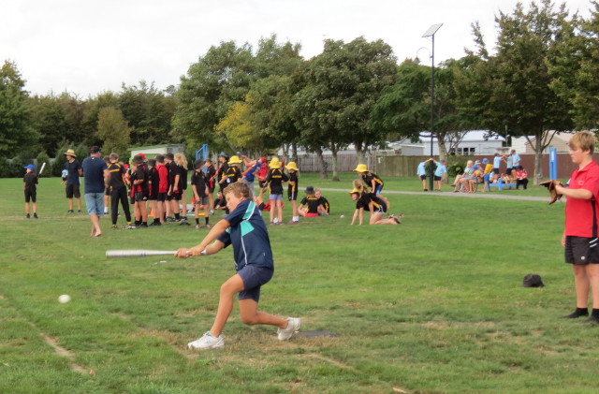
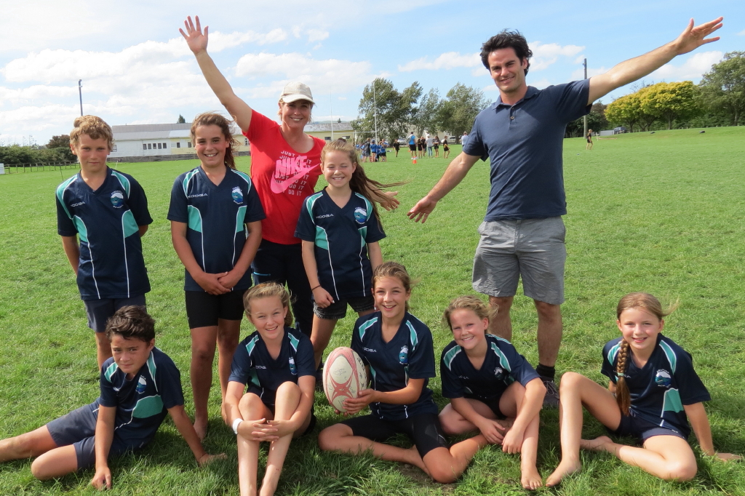
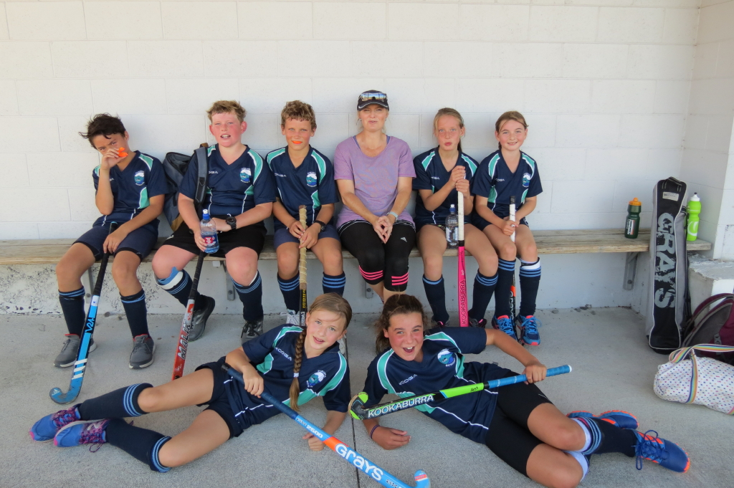
ROOM 2 NEWS –
What do turtles do during the day?- By Willow.

A turtle wakes up at 10am. Turtles like to sleep in. It eats cornflakes for breakfast and then goes for a walk to the nail salon to get it’s shell repainted and polished. Then it goes to Pita Pit and eats a wrap. It goes to the pools for a swim. It goes down a pitch dark slide. The turtle goes home for dinner. He eats coleslaw and sausages. Then he rings his Grandma to see how she is. He feeds his goldfish. Then he brushes his teeth and puts his shark onesie on so that sharks don’t eat him. Then he says goodnight to his goldfish and goes to sleep.

ROOM 1 NEWS – By Jayziah.
The paua shell is blue, brown and purple. It is a circle and it is hard. Paua shells live on the rocks. It has six holes in it. They eat stuff off rocks. They also are ugly on the outside and beautiful on the inside.

ROOM 3 NEWS
The Goal – By Olivia Telford
I was running up the green turf towards the goal, we were facing Lake-View and the clock was ticking. I saw the glistening orange of the cones in the distance and my throat was burning. I could hear the taps of the ball on the sticks and the feet thumping on the turf getting closer to me. Amanda had the ball. She passed it to Jono. Jono passed it to me. With one lightning quick swish of my stick the ball was in the goal! The crowd roared!

YEAR 7/8 TECHNOLOGY FEES
Year 7/8 Tech fees of $57.50 are now due.
Pirinoa School pays 50% of the cost and the remaining 50% is a compulsory fee to be paid by the student please.
If you wish to pay in instalments please see Lynette in office. Thank you.

WEEK 10 LEARNING AWARDS

PRINCIPAL’S AWARD: OLIVIA TELFORD – For following the Pirinoa Path by being active with a positive attitude.

ROOM 2: NIKAU ANDERSON - For writing exceptional stories every day.

ROOM 1: CALEB LANCELEY - For always being polite, helpful and staying on task. Well done Caleb for following the Pirinoa Path.

ROOM 3: OLIVIA TELFORD – For always sharing your knowledge and being beyond helpful.

PLAYGROUND AWARD: LYNETTE BATTY – For a great office lady and having a great smile.
STUDENT ABSENCES
If your child is going to be absent from school please leave a message on our school answerphone, 06 3077829.
Please do not email or facebook absences as these may not be seen.
Thank you.
ROOM 2 NEWS

