Pirinoa School ~Vibrant and Successful learning
Te kakama, te momoho o te ako

Newsletter ~ 5th August 2016 Week 2 Term 3
Principal ~ Troy Anderson Tel: 063077829 Fax: 063077510
Email: office@pirinoa.school.nz
Greetings
It has been a very busy week here at Pirinoa School - we have had the year 7&8 students away at technology, the year 8s away at the Kuranui open day, we have been practising our Kapa Haka routine for the upcoming festival, Janet from the library has been in and today we started our pilot programme of Pest Control.

The Pest Control programme has come about as Fonterra Grassroots has gifted the Aorangi Trust $5000 to go towards pest control. Kahutara and us have joined together to get the project off the ground, with 9 students taking part. We will have cameras and lure stations setup around the school to see what pests we have roaming the school grounds. Once we have monitored these cameras and decided what pests are out there, then we will set up the Rodent Detectors A24, which is mechanized by gas and shoots out a heavy duty rod which kills the pest. These traps will be set after school and turned off before school starts. We have a group of 5 students: Nikau Love, Kala Baird, Charlotte Kerrison-Jones, Maralyse Whiteman and Jono Didsbury who are leading this programme and will pass on their knowledge to others.

Please double check that your Class Dojos are set up - you need either a smartphone to use the app or you can use a normal web browser. The reason for this is that we are trialling sending pictures and videos home of examples of students learning. If this is successful it will replace the brag book.

Have a great weekend and go the Hurricanes!!!

Your Principal
Troy Anderson

 | AUGUST
Sunday |  | Monday | Tuesday | Wednesday | Thursday | Friday | Saturday
 |  | Vision & 1  Hearing tests | Y7/8 Tech 2 | Kuranui Open Day 3 | Kuranui 4 evening | 5 | 6
7 |  | 8 | Y7/8 Tech 9 | 10 | 11 | 12 | 13
14 |  | 15 | Y7/8 Tech 16 | 17 | Matharapa 18 | 19 | 20
21 |  | 22 | 23 | 24 | 25 | 26 | 27
28 |  | 29 | BOT mtg. 30 | 31
 | SEPTEMBER
 |  |  |  |  | 1 | 2 | 3
4 |  | 5 | 6 | 7 | Kuranui 8 Enrolments | 9 | 10
11 |  | Cleanup NZ 12  Week | 13 | 14 | 15 | 16 | 17

Did you know:
- SAUSAGE SIZZLE: Thank you to RENEE who is cooking on Friday 5th August.
- YUMMY STICKERS: Keep collecting those stickers and cut-out labels and bring to school in Term 3. Help us earn some new sports equipment from them. Thank you.
- PARENT DONATIONS/INVOICES: For those with outstanding amounts, please find attached an invoice. Whilst the parent donations are voluntary, we do appreciate your help as they go towards topping up learning resources for our students and benefit everyone. Any technology fees or stationery charges are compulsory and need to be paid as the school has already had to pay these amounts on your behalf.
Thank you for your assistance.
CRYPTIC DINNER
This has been postponed due to the Super rugby finals being played.
The new date is: Saturday 20th August.
CONGRATULATIONS!!!
Congratulations to Charlotte Jephson who has been chosen for the Under 13 Hockey Rep team to compete for the Rawleigh Cup.
Charlotte will be travelling to Hawkes Bay and Stratford representing the Wairarapa…what a tremendous achievement – we are all very proud of you Charlotte!!
Today we launched our Pest Control Initiative with Kahutara School and the Aorangi Trust. We have a group of students who are leading the pilot programme where we will attempt to eradicate pests from our school and surrounding areas.
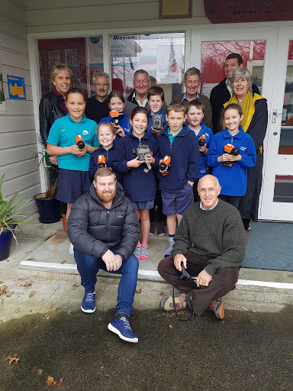
HOCKEY DRAW:
Monday 8th August: -v- Hadlow @ 6pmJNLT Turf. Oranges: Shakia.
Monday 15th August: -v- Dalefield @ 5pm JNLT Turf. Oranges: Te Atawhai.

RUGBY RESULTS:
U6: Loss U8: Win U9: Win U11: Loss
U13: Win
RUGBY DRAW –
Saturday 6th August:
U6: 9.30am vs Martinborough @ Greytown F1.1; 10am –v- Carterton White @ Greytown F1.1.
U8: 9.30am BYE. 10am –v- Gladstone Black @ MRS F2.1
U9: 9.30am –v- Eketahuna @ Marist F2b.
U11: 10.30am –v- Marist @ Martinborough F2. U13: 10.30am –v- MRS Black@ MRS F1.

STUDENT AWARDS
PRINCIPAL’S AWARD: MARSHALL LOVE -
Marshall you have had a great couple of weeks. You have been focused on your learning, helping others and you have a great attitude. Keep up the awesome effort - it's great to see.
SAVANAH CLARK - Savanah you have had a great week, you are working so hard in all areas of your learning, you are really focussed on what makes you successful. Well done keep it up.

ROOM 2: MADDIE KERRISON-JONES – For showing enthusiasm in Jump Jame.
CHARLIE KERRISON-JONES – For awesome narrative writing.
ROOM 2 WEEKLY NEWS
It has been a very busy week learning new things. We have learned how to compare articles with narratives. We have finally got the hang of it! We have a reading rotation to do which includes spelling sheets and reading board games. For maths we are concentrating on basic facts. We also did a Ikan test last week. We are doing painted setting scenes to create children's books for Room 3 and Room 1. Then we created a dance to music in several groups about the Papatuanuku and Ranginui separation. Today Shakia and Te Atawhai read an article about the olympics and we are doing Jump Jam for PE and Health. For writing we are doing Room 2’s Weekly news!!!

By Isla Weatherstone.

NETBALL RESULTS:
Stars: Loss.
Swans: Win by default
Steel: Win.
NETBALL DRAW: Saturday 6th August.
All games at Kuranui.
Steel –v- MIS Tactix @ 9am Ct 4.
Stars –v- Te Kura Rangiatea @ 10am Ct 5.
Swans –v- Carterton Kowhai @ 11am Ct 4.

ROOM 2 NEWS

