Pirinoa School ~Vibrant and Successful learning
Te kakama, te momoho o te ako

Newsletter ~ 26th February 2016 Week 4 Term 1
Principal ~ Troy Anderson Tel: 063077829 Fax: 063077510
Email: office@pirinoa.school.nz
Kia Ora Koutou It was great hearing of all the swimming success from the Cluster Swimming Sports that were held on Tuesday. Our students did very well and it was mentioned that the progress that Pirinoa students have made in the pool is a credit to parents and the school, so well done.

We have had the first week of Raroa Catering, which is where we cater an evening meal and pudding to children that are staying at Lake Ferry Camping Ground. I was there on Wednesday and it ran very smoothly. So thank you to everyone that has helped with cooking, prep, food donations and serving. A special thank you to Kim Whiteman and Donna Clark for organising and cooking everything. Please remember to look at the roster for next week and if you aren't sure of anything ring me or Kim Whiteman.

Make sure you write these important dates on the calendar:
Parent teacher interviews are next Thursday the 3rd of March, 3.30-5.30pm so please book a time to see Mrs Locke (Rm2) or Ms Pickering (Rm1). If you would like to talk to me about your child's learning or anything else then please choose a time as well.

Please write down the next fundraising meeting - this meeting is on Monday 14th of March. These meetings are for everyone, so come along, get involved and then you will know what's going on.

And lastly on Tuesday 29th of March there is a Data Evening. This is where, as a school community, I hope to get as many parents at school as possible to look at the achievement data of our students and work together to answer some questions like: what's the data telling us? where to from here? and I hope that we can start to create a graduate profile, so what do we hold, as important, for our students to have when they are leaving at the end of year 8?

Super Rugby starts tonight, just in case you forgot.
(Go the defending Champions, The Highlanders)

Your Principal, Troy Anderson

 |  |  | MARCH
 | Su |  | Mo |  |  | Tu |  | We |  | Th |  |  | Fr |  | Sa
 | 28 |  | 29 |  |  | Y7/8 Tech 1  Raroa catering |  | Raroa 2 |  | Parent/ 3  Teacher mtgs |  |  | I/school swim 4  Sports |  | Carparking 5
 | 6 |  | 7 |  |  | Raroa 8 |  | Raroa 9 |  | 10 |  |  | 11 |  | 12
 | 13 |  | F/raising mtg 14  7pm |  |  |  |  | 16 |  | 17 |  |  | 18 |  | 19
 | 20 |  | 21 |  |  | 22 |  | Turanganui Stn catering 23 |  | 24 |  |  | Good Friday 25 |  | 26
 | 27 |  | Easter Monday 28 |  |  | BOT mtg 29  SCHOOL CLOSED |  | Back to 30  School |  | 31
 |  |  |  |  | APRIL
 |  | Su |  | Mo |  |  | Tu |  | We |  | Th |  | Fr | Sa
 |  |  |  |  |  |  |  |  |  |  |  |  | 1 | 2
 |  | 3 |  | 4 |  |  | 5 |  | 6 |  | Vision & 7 Hearing |  | 8 | 9
 |  | 10 |  | 11 |  |  | 12 |  | Rotary 13 dinner |  | 14 |  | End of T1 15 | 16

THANK YOU TO
NORTHFUELS…

Did you know?
- ASSEMBLY: Every Friday at 12.10pm followed by sausage sizzle.
- SAUSAGE SIZZLE: Thank you to KAMA who cooked for us today.
SARAH SUTHERLAND is on duty next Friday, 4th March. We still have two days to fill, 1st April and 1st July…if you haven’t already offered to do a turn, please contact Lynette. Thank you.
- SCHOOL BANKING: Every Tuesday. See Lynette if you would like your child to take part in this.
- FUNDRAISING MEETING: Monday 14th March at 7pm, look forward to seeing you there. Please note change of date.
- NETBALL REGISTRATIONS: Registration forms are out now.
- SCHOLASTIC orders, together with payment, due at school by Monday 29th Feb.
PIRINOA SCHOOL CLEANER
We are currently looking to fill the position of School Cleaner. This role would entail general school cleaning, i.e. washing windows, vacuuming floors, wiping down walls, cleaning toilets etc.
The hours will be one hour after school everyday, five days a week.
Some cleaning will need to take place during school breaks.
If you are interested in the position or have any queries, please contact Troy 3077829.
Applications close Friday 4th March 2016.

FOR SALE…
Goggles $7.00 Swim caps $3.00
Available from the school office.

FAIR CARPARKING ROSTER
 | 5th March
7.30-9am | Whiteman
8.30-10.30 | Weatherstone
9.00-11am | Love – Jo
10.30-12.30 | Anderson
11.00-1pm | Jope
12.30-2pm | Fellerhoff
12.30-2pm | Telford
2.30-4.30pm | Hume

ROOM 1 WEEKLY NEWS.
This week in Room 1 we have been writing stories about the things we do. We have been trying to include who, what, where, when and why in our stories. Our swimming is improving and some of the children are learning to breathe in the water. Congratulations to Edward and Aria for swimming really well on Tuesday at the Swimming Sports in Featherston. Today we have been making sunflowers with coloured paper and sand. They look cool!! By Rowan Anderson

A great big thank you to Northfuels and the farmers who contribute to this scheme…our school received $1000 of new sporting equipment…amazing!!
RAROA CATERING

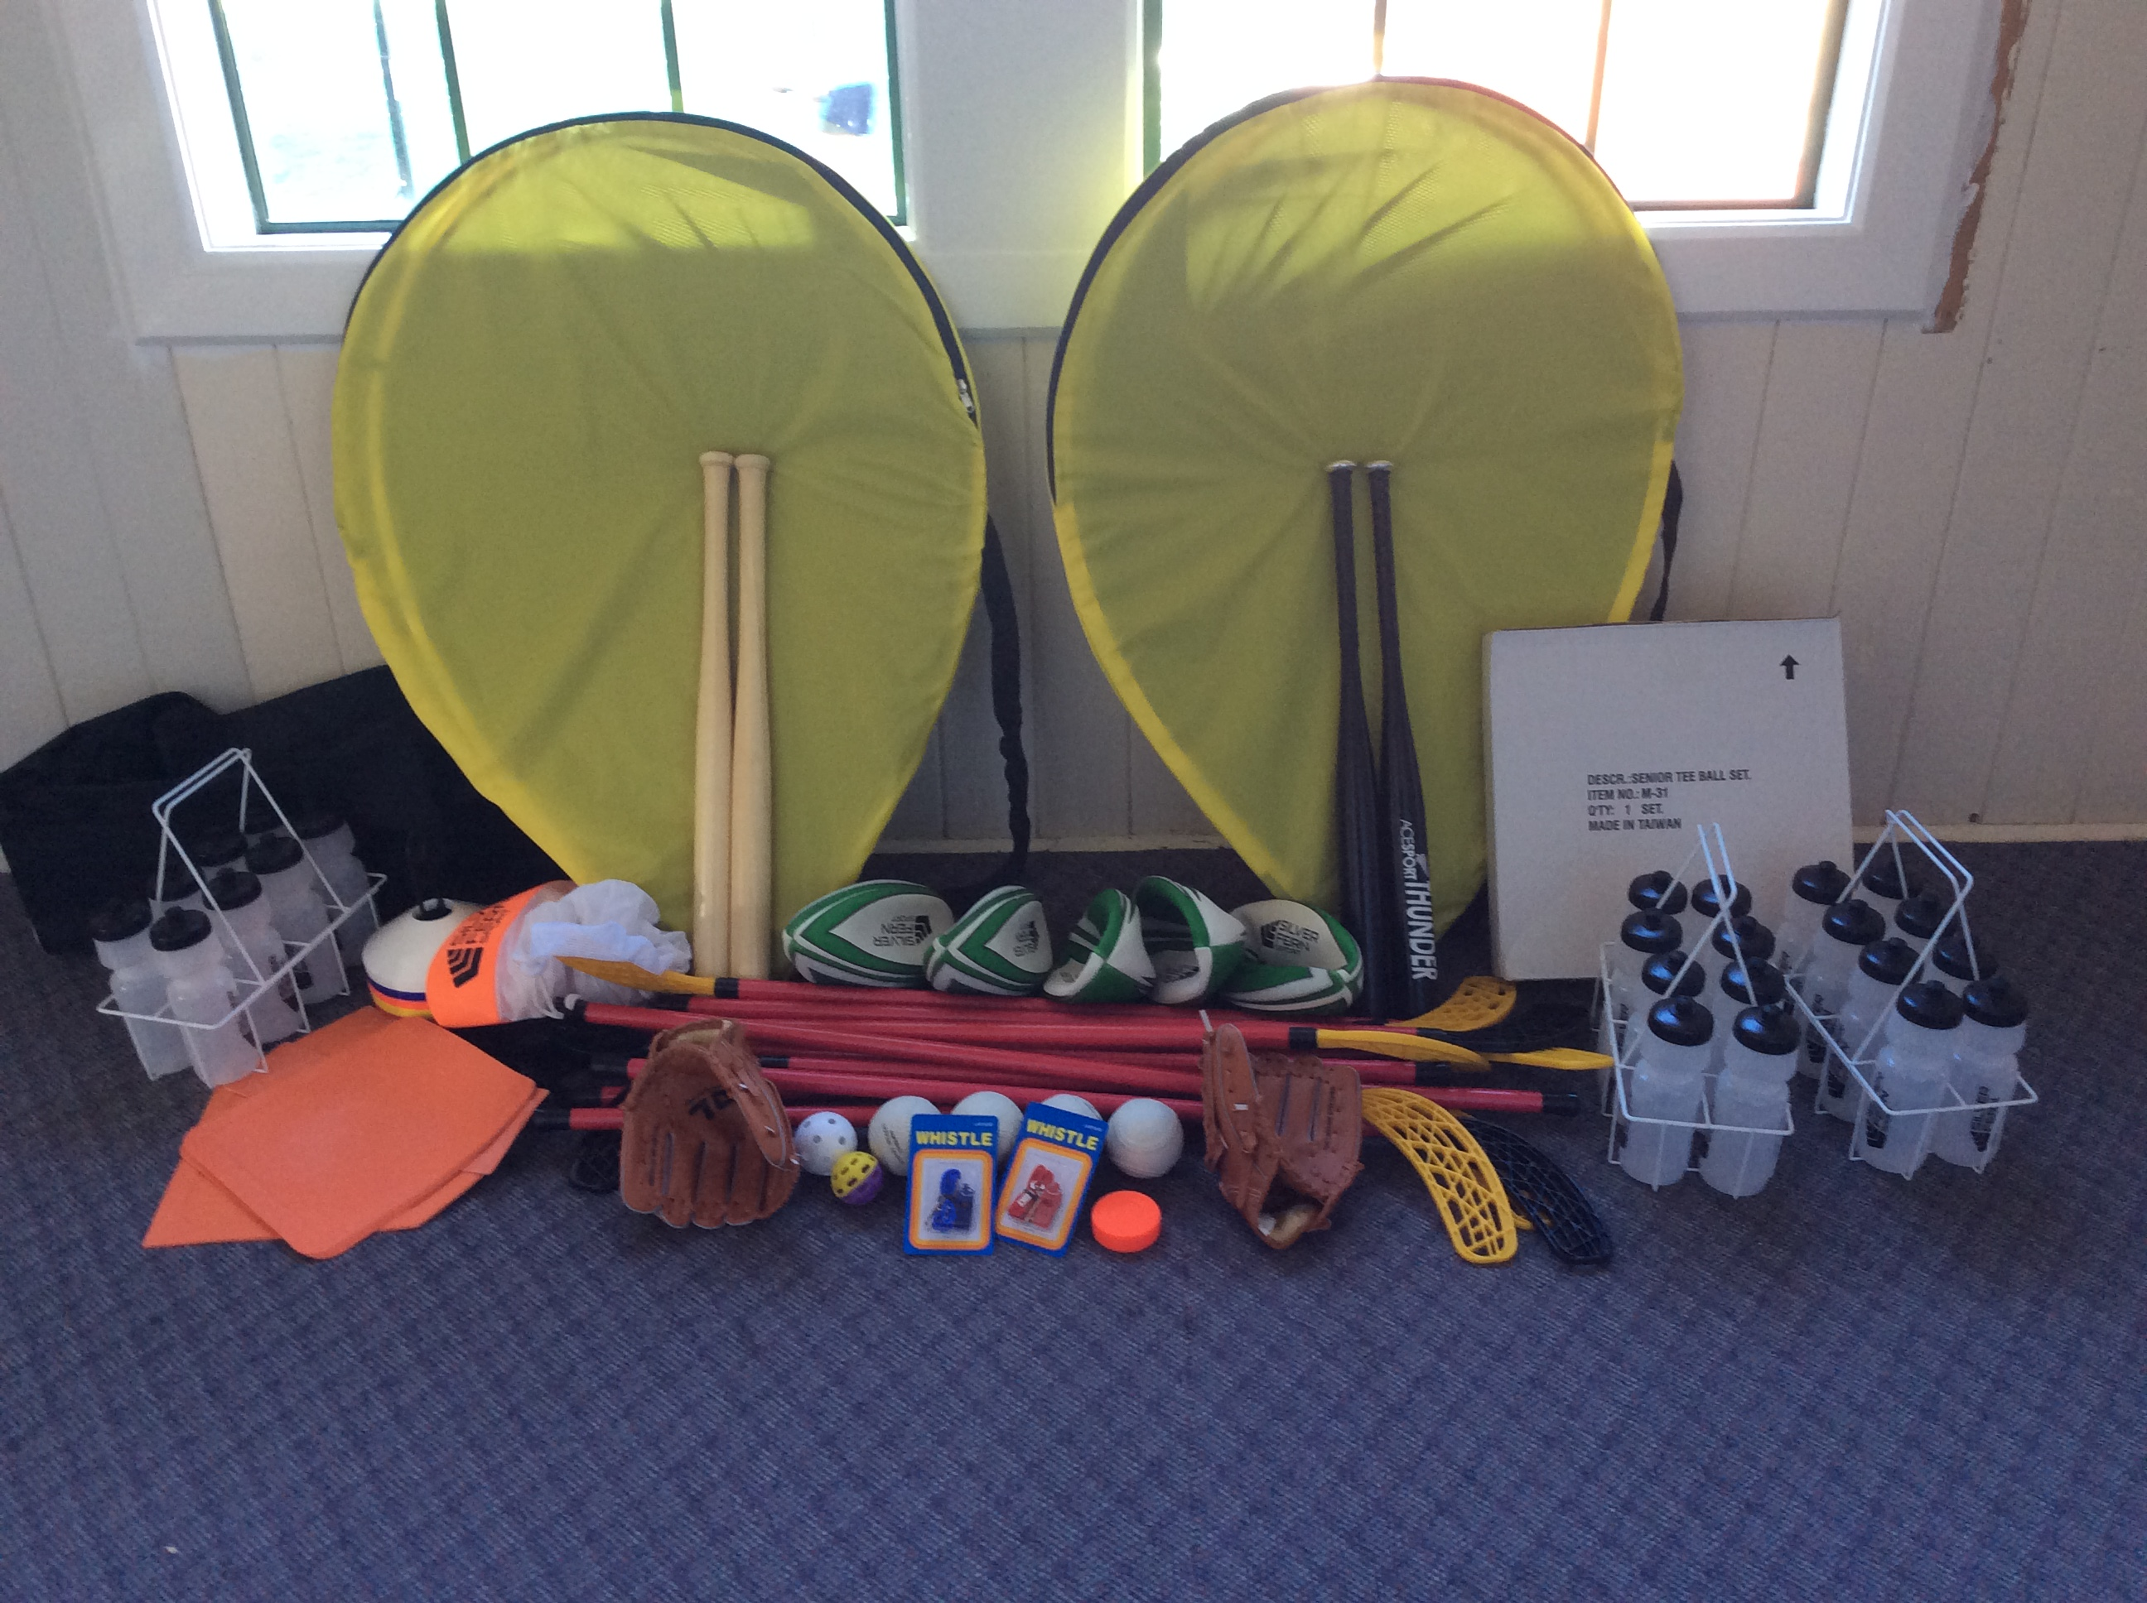
 | Crumble |  | Prep |  | Cooking |  | Serve/Dishes
1 March |  | Dennes |  | Boyle |  | Jephson |  | Hume
 |  | Macdonald |  | Jope |  |  |  | Love
2 March |  | Williams |  | Wells |  | Anderson |  | Baird
 |  | Tiopira |  | Fellerhoff |  |  |  | Love
If you are unable to make your rostered time please arrange a swap with someone else.
Sonya or Donna will be there at all times.
Crumbles (Roasting dish size) to be at school by lunchtime or at the Lake Ferry camp ground, hot, to serve at 6pm. If you require any ingredients, please let Kim know 3077881.
Those on prep need to meet at 1pm at Donna’s, 101 Lake Ferry Road, Lake Ferry. All veges will be there. Those on serving and dishes need to be at Donna’s, 101 Lake Ferry Road at 5.15pm.
Thank you everyone in advance for the great team effort. Kim.

