Pirinoa School ~Vibrant and Successful learning
Te kakama, te momoho o te ako

Newsletter ~ 11th March 2016 Week 6 Term 1
Principal ~ Troy Anderson Tel: 063077829 Fax: 063077510
Email: office@pirinoa.school.nz
Good Afternoon

It has been a very exciting week here at school, our composition board is up on the walls in the corridor and it looks great, Room 1 has moved into their classroom and are enjoying their green room and having their space back. Room 2 have moved over to the library and should be back into their classroom by Wednesday and that is the day that they should be all finished which will be great.

I have created a Facebook page to help with communication home, as I know of a few people that aren't getting their newsletters. Newsletters go home every week on Fridays and they do have some very important information in them. We also have a website where you can check the newsletter or any other important information - just double click on the latest news.

We have a Fundraising meeting this Monday night the 14th, at 7pm at school to look at the next two fundraisers and currently the Home & School Memorandum of Understanding is being reviewed and I am taking a proposal to the next BOT meeting. Following this I will then talk briefly to that at the Data Evening on the 30th of March.

A permission slip will be going home today for any children interested in playing Hockey on Monday nights, it's for years 4-8. There will also be a permission slip for all students, because the children are performing their Kapa Haka and being part of the Powhiri at the Marae for the South Wairarapa Whanau Hui. All parents are welcome to join us in the evening, the children need to be at the Marae at 5pm and we will be finished by 7pm.

Troy Anderson
Principal Pirinoa

 |  |  | MARCH
 | Su |  | Mo |  |  | Tu |  | We |  | Th |  |  | Fr |  | Sa
 | 6 |  | 7 |  |  | Raroa 8 |  | Raroa 9 |  | 10 |  |  | 11 |  | 12
 | 13 |  | F/raising mtg 14  7pm |  |  | Kohunui 15  Marae 5-7pm |  | 16 |  | 17 |  |  | 18 |  | 19
 | 20 |  | 21 |  |  | 22 |  | Turanganui Stn catering 23 |  | 24 |  |  | Good Friday 25 |  | 26
 | 27 |  | Easter Monday 28 |  |  | BOT mtg 29  SCHOOL CLOSED |  | Back to 30  School  Data Evg. 7pm |  | 31
 |  |  |  |  | APRIL
 |  | Su |  | Mo |  |  | Tu |  | We |  | Th |  | Fr | Sa
 |  |  |  |  |  |  |  |  |  |  |  |  | 1 | 2
 |  | 3 |  | 4 |  |  | 5 |  | 6 |  | Vision & 7 Hearing |  | 8 | 9
 |  | 10 |  | 11 |  |  | 12 |  | Rotary 13 dinner |  | 14 |  | End of T1 15 | 16

Did you know?
- ASSEMBLY: Every Friday at 12.10pm followed by sausage sizzle.
- SAUSAGE SIZZLE: Thank you to CAROLYN who cooked for us today.
KIM MACKLIN is on duty next Friday, 18th March. We still have two days to fill, 1st April and 1st July…if you haven’t already offered to do a turn, please contact Lynette.
- FUNDRAISING MEETING: Monday 14th March at 7pm, look forward to seeing you there.
- YUMMY STICKERS: Are you collecting your Yummy Stickers??
WOW…Look at our Green Room and what a fantastic update for Room 1.
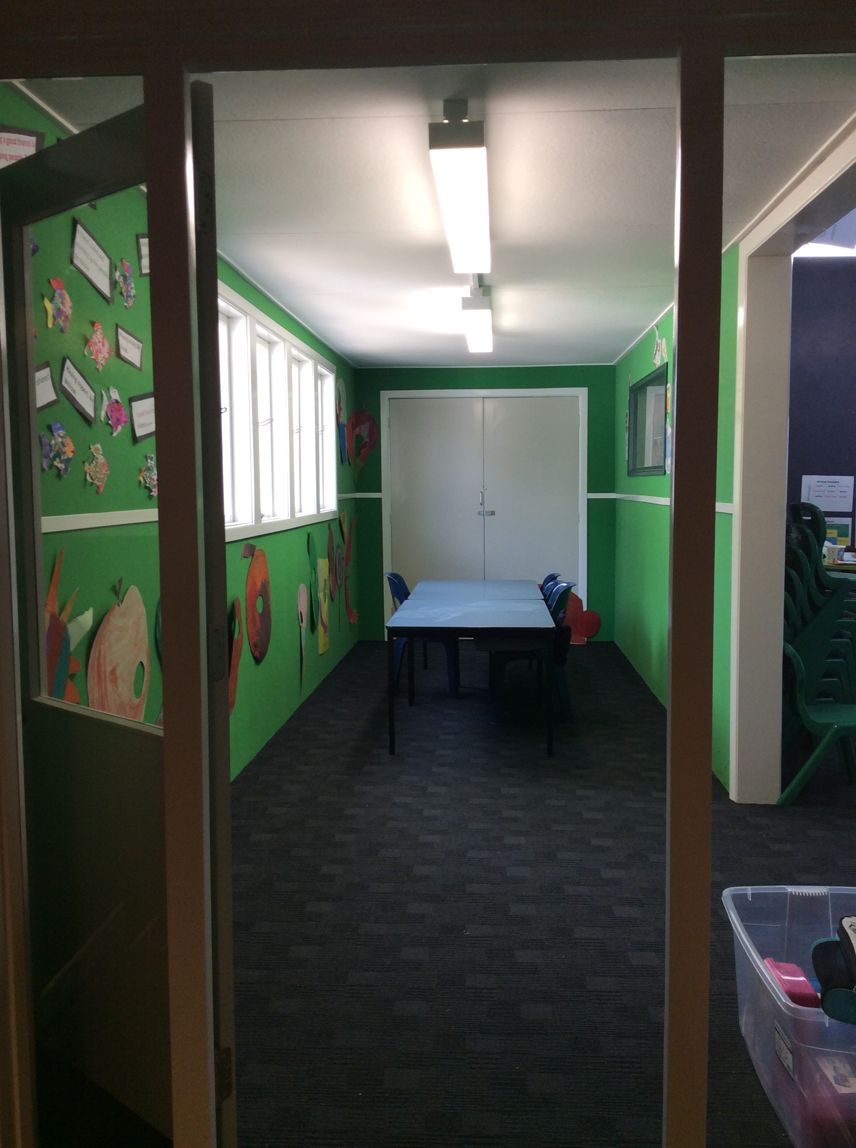
ROUND THE VINES Martinborough
Fun Walk/Run Sunday 20 March 2016. Register online www.roundthevines.org.nz
Organised by and in support of Martinborough School. Lots of spot prizes and a chance to win 2 night’s accommodation at Peppers incl. 2 cooked breakfasts, 4-course meal for 2, plus Schoc Chocolates and a bottle of bubbly.
ROOM 1 WEEKLY NEWS.
On Wednesday it was sunny. After school we did boxing. You have to pay the man two dollars. Then we did some skipping.
By Edward.
On Thursday I ate some Easter Eggs. I ate some eggs. It was delicious.
By Jaiden.
On Thursday I had an Easter Egg. I like chocolate.
By Willow.
On Friday morning it rained. Then it was sooo windy and the big trees swayed. Also some tree branches broke.
By Aria

BOARD OF TRUSTEES ELECTIONS
Election date: Friday 3rd June 2016.
Every state and state integrated school in NZ is currently undergoing a trustee election process.
At our school we are looking for five parent trustees, although you do not need to be a parent to stand for election.
We will be holding an informal information evening shortly and invite you to come along, have a chat with our existing Board members and get some information on what it’s all about.
Watch this space!!
ROOM 2 NEWS
Room 2 started off with an amazing week. Room 1 have moved back into their classroom and it looks fabulous. This week room 2 played Ki-O-Rahi on Wednesday. We also had Kapa Haka practice on Thursday. Room 2 have moved into the library until our new carpet gets put in. There was Maralyse’s club on Tuesday, then Kala and Isla’s final club on Thursday at lunchtime.
By Te Atawhai Love.

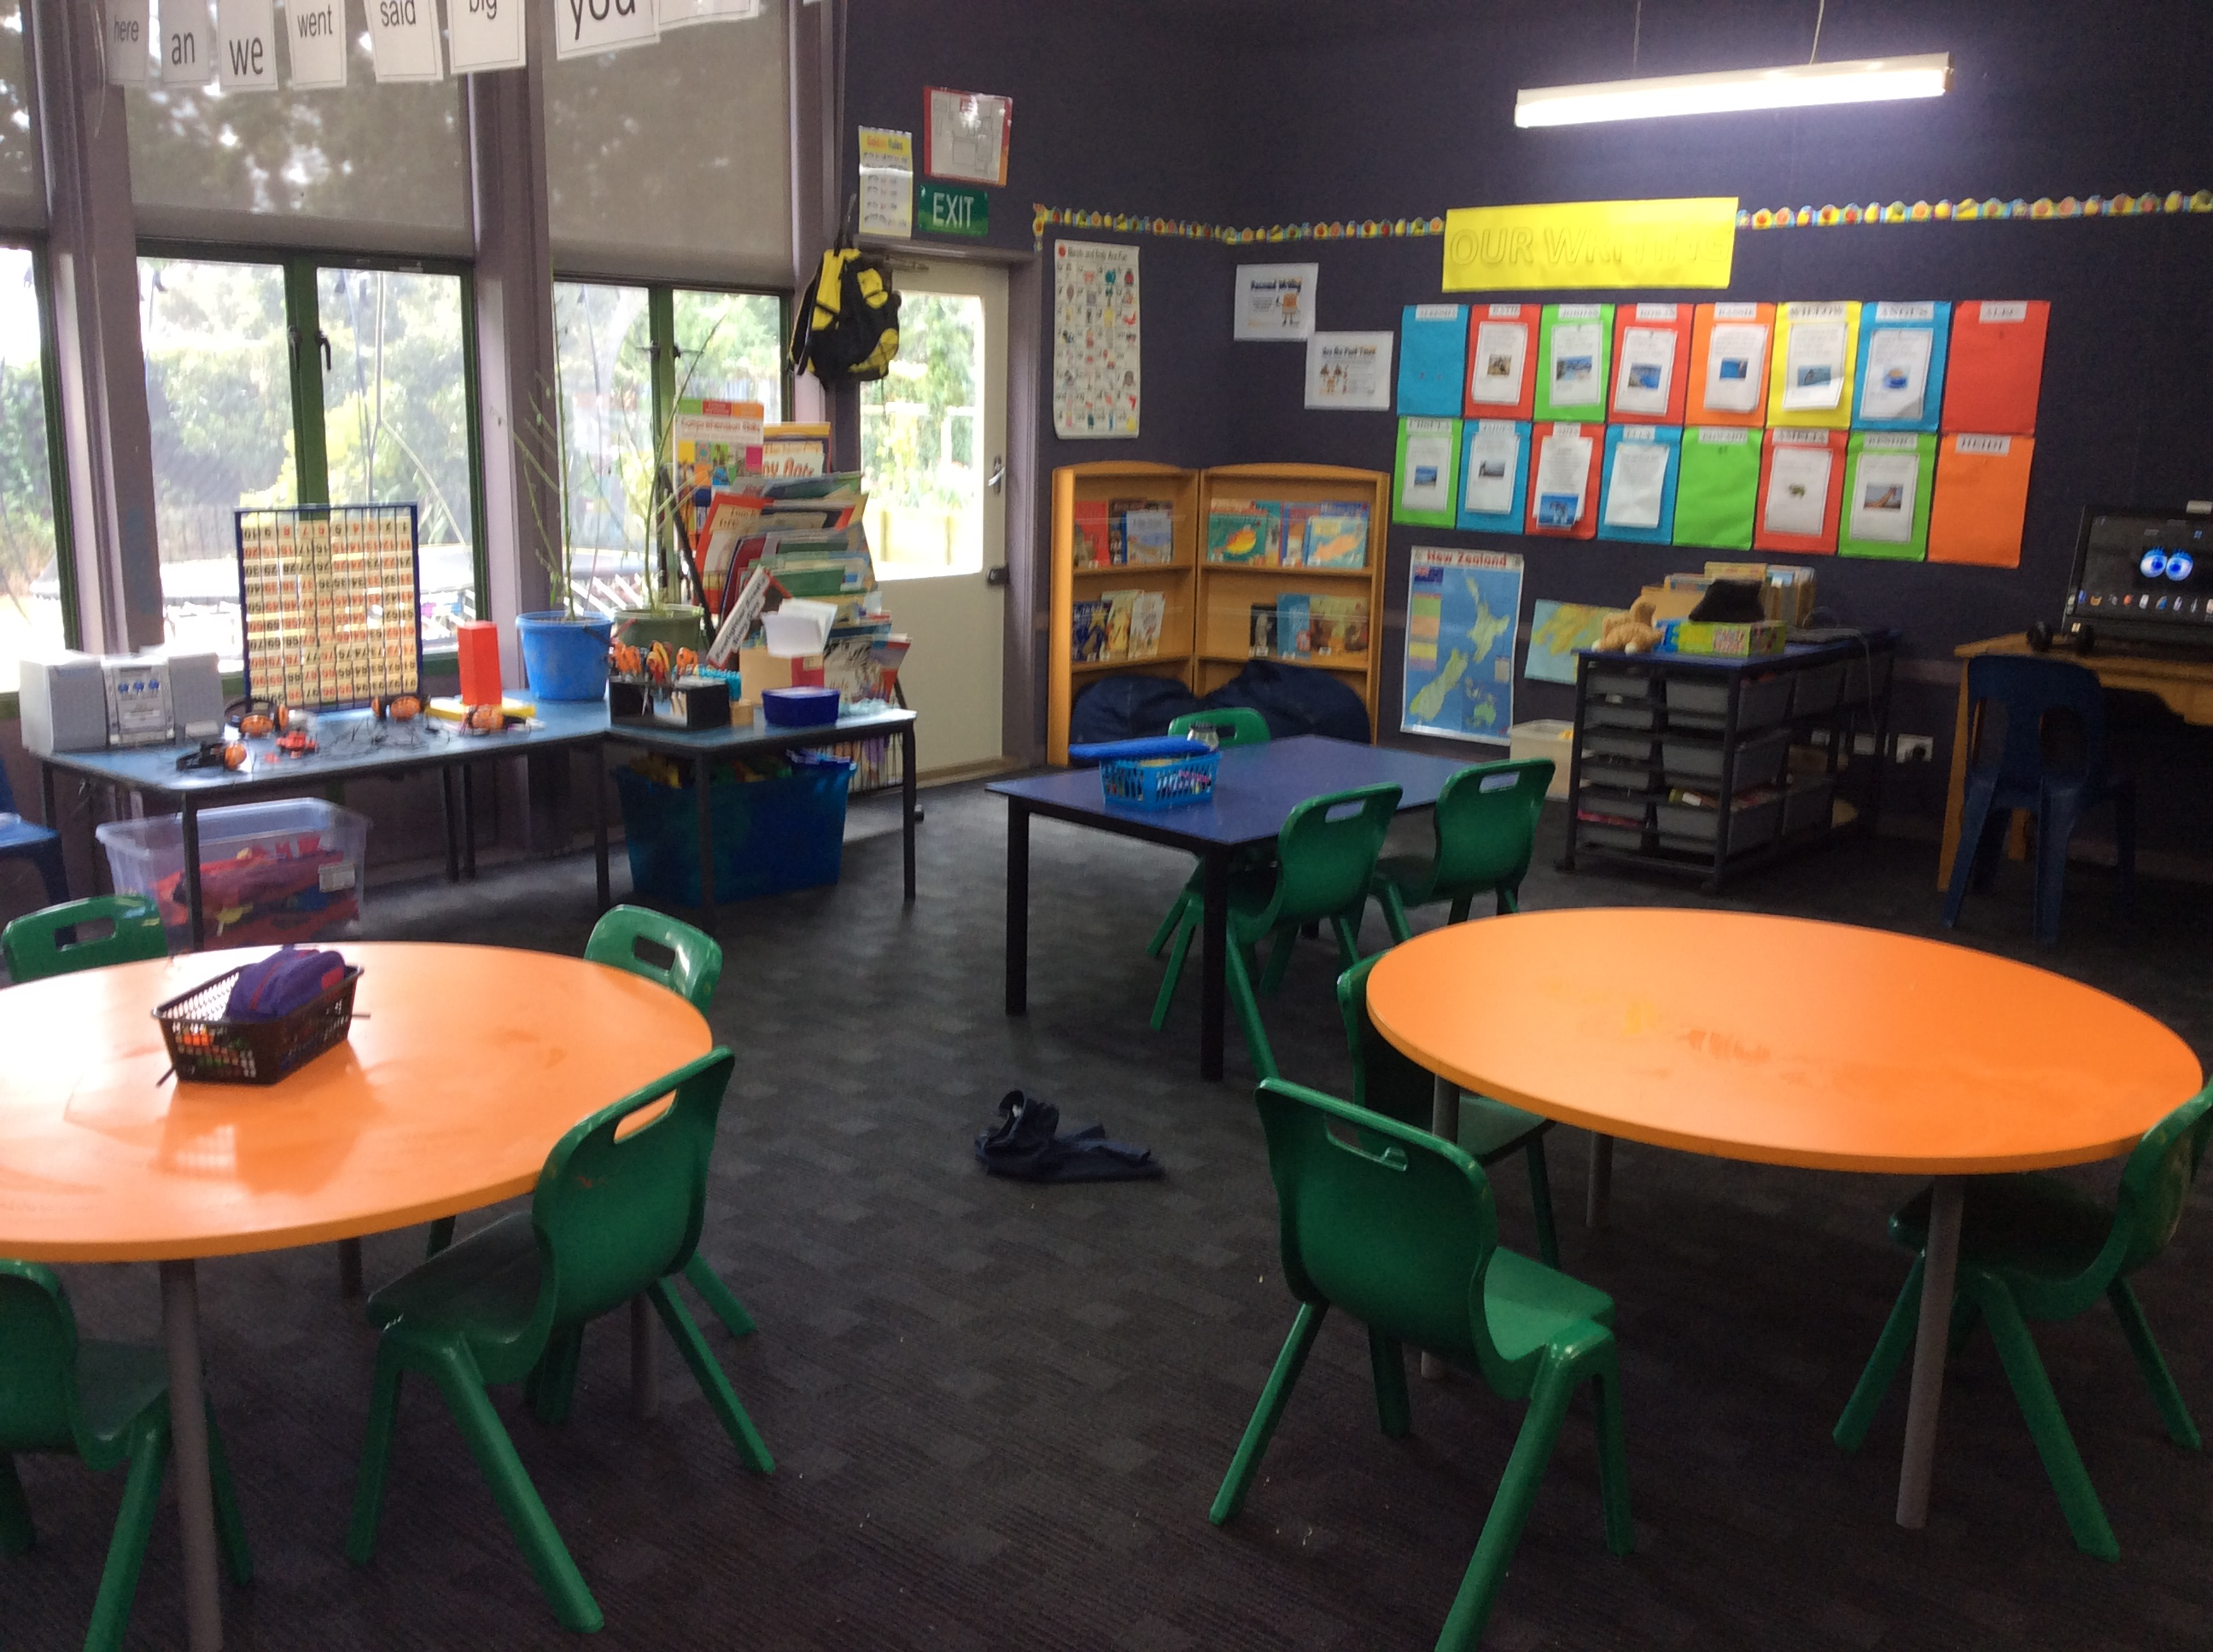
STUDENT AWARDS

PRINCIPAL AWARD: NIKAU LOVE. Nikau, I have been very impressed with your leadership during House Meetings and Council Groups. You are very focused on your learning, keep up the great work.

ROOM 1: ARIA WHITEMAN - for using a variety of ways to problem solve in Math.

ROOM 2: KALA BAIRD - for great leadership and teamwork in running a successful club for 3 weeks, and,
ISLA WEATHERSTONE - for great leadership and teamwork in running a successful club for 3 weeks.

