Pirinoa School ~Vibrant and Successful learning
Te kakama, te momoho o te ako

Newsletter ~ 2nd December 2016 Week 8 Term 4
Principal ~ Troy Anderson Tel: 063077829 Fax: 063077510
Email: office@pirinoa.school.nz
Kia Ora Whanau

Wow, wow, wow, what an amazing production !!!! The children were absolutely amazing and really stood up and produced a quality show. I couldn't be more proud of the how they all performed, also the sound boys at the back were fantastic, Ms Woodhouse and Ms Pickering for their awesome effort of props and choreography, it was very heart warming watching it all come together.

The end of the year is fast approaching and with that comes excitement and anxiety of 2017. It's really important to keep selling the message that there is still eight days of school left and it's important to keep to the Pirinoa Path.

On Friday the 9th starting at 1pm we will be holding our end of year Swimming Sports. Lunch will take place at 12pm so come along for a FREE BBQ for all !!!!.

Our PB4L prize has been chosen through having the most stickers and it's the Water Afternoon. This will take place on the last Tuesday of term, the 13th. Please send your child along to school with their togs and a sunhat.

Prize giving will be on Wednesday the 14th of December at 6pm, which is the last day of the school term. It's important that your child/ren come to school that day in mufti so that their uniforms can be nice and clean for prizegiving.

Year 8 dinner is coming up. Sonya and Donna are organising it, they will be touch with you however if you have any questions please phone them.

We need a ‘before Christmas’ tidy up, so a working bee has been planned for Sunday the 11th at 10am. Please come along and give us a hand for 2 hours and you will receive a FREE BBQ.

Your Principal
Troy Anderson

 | DECEMBER
MONDAY |  | TUESDAY | WEDNESDAY | THURSDAY | FRIDAY | SATURDAY | SUNDAY
 |  |  |  | 1 | 2 | 3 | 4
Open meeting 5  parents/community |  | 6 | 7 | 8 | School swim 9  Sports | 10 | Working 11  Bee 10am
12 |  | Water Day 13 | Term 4 ends 14 | 15 | 16 | 17 | 18

Did you know:
- SAUSAGE SIZZLE:
Thank you to Sara for cooking sausage sizzle today.
Alex Weatherstone: 9th December.
- GEOFF’S PHOTOS: If you have received any of Geoff’s photos attached to the last newsletter and would like to keep them, you just need to make a small donation to the school which we will then transfer to Geoff who will pass it onto the children in Uganda. Your donation will be very much appreciated by them.
- Pirinoa Store now has swap a bottle gas bottles. $35.90. Bottles need to be in good condition.
- MARTINBOROUGH LIBRARY READING PROGRAMME: Places filling fast…pop into library or phone/email to get your child/ren enrolled.

Watties Cans…Thank you to everyone who helped by donating cans to be distributed by the Salvation Army.
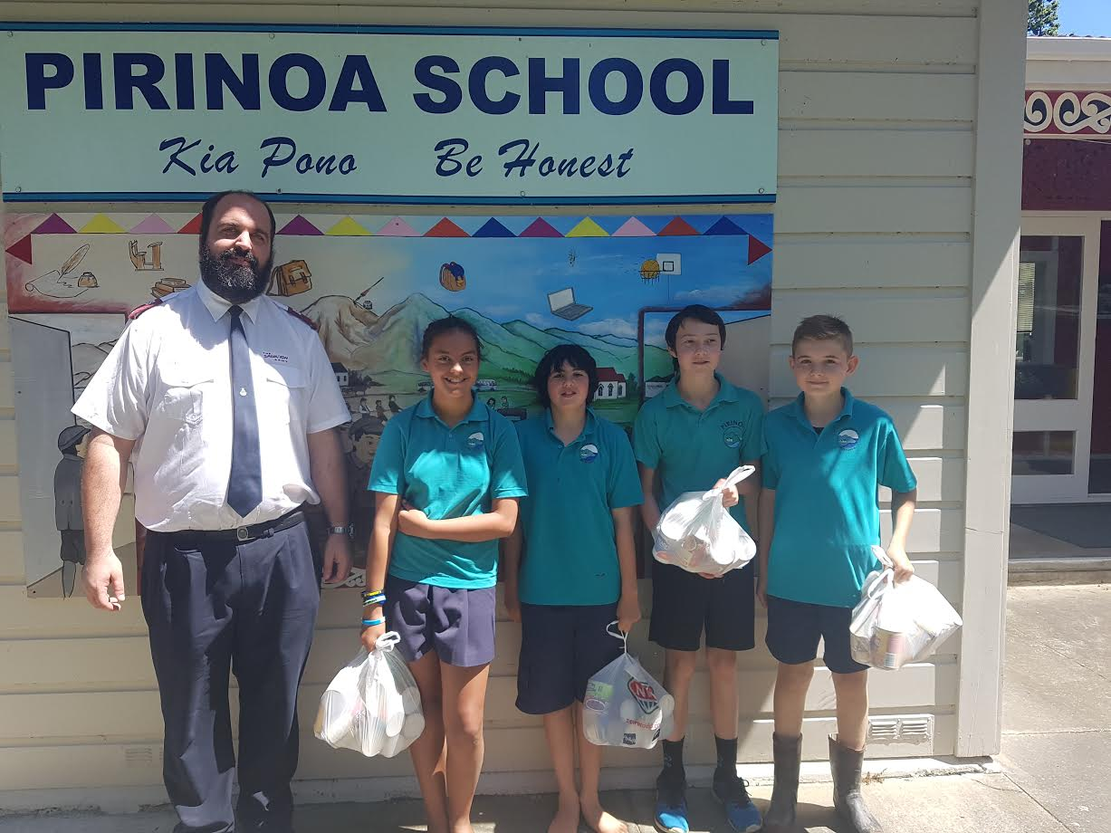
Pirinoa School Cleaner Vacancy
As our current cleaner is heading overseas our cleaning position has come available. This position is for 8 hours a week, an hour and half every day after school and during the holidays the 8 hours are made up by spring cleaning, washing windows etc.
For more details and expression of interest please contact the school or email principal@pirinoa.school.nz

END OF YEAR PRIZEGIVING Wednesday 14th December at 6pm.
End of year children/s gifts – To a value of $10 per gift. Please ensure they are handed into office by Monday 12th December, wrapped and clearly named. If you have pre-schoolers attending prizegiving please send a gift for them if you wish. Thank you.
Supper - We would like every family to bring along a plate for a shared supper please.
Roster for dishes: The following families are rostered on for dishes – McDowall, Macdonald, Robinson, Sutherland. (Families are rotated on an alphabetical system each year, thank you for your help.)

FROM ROOM 1
At the Pirates –v- Mermaids production I was a mermaid and all my friends were mermaids too.
By Heidi Didsbury.
LIMERICKS FROM ROOM 3
There once was a ballet dancer.
Who was a magnificent prancer.
She lived on the stage,
Had a sister called Paige,
Her favourite word was consir!
By Lucy Didsbury.

I once had a cat,
Who married a rat,
They got married in the sun,
With a raspberry bun,
And they sat on a pink mat.
By Aria Whiteman.

By Polly Telford
Verse 1
You might have imperfections
But don’t let them hold you back
You might have people who put you down
But don’t let them get to you
Cause what they say isn’t true
Chorus
If you ever feel down
If you ever feel lost
If you ever feel alone
Be sure to take my hand
Baby (2x)
If you feel like you’re falling
I’ll take your hand
And give you my wings so you can fly
Verse 2
You might crash
But you get up again
Your light might burn out
But your soul can light up the world
Chorus
OH OH OH (2x)

WEEK 7 LEARNING AWARDS

PRINCIPAL’S AWARD: JACK MCDOWALL - You were absolutely amazing at production, you lead the school. You are growing into an awesome leader, keep up the awesome attitude. Well done.
ROOM 2: MAIYAH FELLERHOFF - Your resilience has been great, bouncing back quickly if the situation demands it. Applying yourself to everything that you do in class, you have achieved a lot of work in all areas of your learning. Great job being a narrator in the School Production!
ROOM 1: RYAN JOPE - For having a great attitude to learning in reading and writing.
HUNTER KERRISON-JONES - Excellent work in mathematics
ROOM 2 NEWS

