Pirinoa School ~Vibrant and Successful learning
Te kakama, te momoho o te ako

Newsletter ~ 1st April 2016 Week 9 Term 1
Principal ~ Troy Anderson Tel: 063077829 Fax: 063077510
Email: office@pirinoa.school.nz

Kia Ora Whanau

I hope everyone enjoyed their long weekend and managed to spend some time catching up with families and friends. The students have come down off their sugar, chocolate high and have been busy learning and focusing on their school work.

We had a Board meeting on Tuesday night and during this meeting we discussed the money that was raised at the recent fundraising event at Turangaui Station. Currently we are going to install the heat pumps and finish off Room 2 and the corridor upgrade. Once all the money has been deposited and the final amount is known, I will then inform you of any other spending and how much we are banking.

We also had a Data Evening where we discussed the latest Data results, the Memorandum of Understanding for Fundraising which will replace Home and School, and we created a list of ideas to help form a Year 8 graduate profile.

Don't forget to turn your clocks back on Sunday for daylight saving.

Troy Anderson
Principal Pirinoa

 |  |  | APRIL
Su |  | Mo |  | Tu | We | Th |  | Fr | Sa
3 |  | 4 |  | 5 | 6 | Vision & 7 Hearing |  | 8 | 9
10 |  | 11 |  | 12 | Rotary 13 dinner | Ki-O-Rahi 14  Seed collecting  Wairio Wetlands |  | End of T1 15 | 16
17 |  | 18 |  | 19 | 20 | 21 |  | 22 | 23
24 |  | 25 |  | 26 | 27 | 28 |  | 29 | 30
 | MAY
Su |  | Mo |  | Tu | We | Th |  | Fr | Sa
1 |  | Start of T2 2 |  | Y7/8 Tech 3 | 4 | Hockey Skills 5 |  | 6 | 7
8 |  | 9 |  | Y7/8 Tech 10  Planting L.Onoke | BOT mtg 11 | Hockey Skills12  Y8Leadership camp |  | Y8Leadership 13  Camp | 14
15 |  | 16 |  | Y7/8 Tech 17 | 18 | Hockey Skills19 |  | 20 | 21
22 |  | 23 |  | Y7/8 Tech 24 | 25 | Hockey Skills26 |  | 27 | 28
29 |  | 30
 | JUNE
Su |  | Mo |  | Tu | We | Th |  | Fr | Sa
 |  |  |  | 31 | 1 | 2 |  | 3 | 4
5 |  | Queens B’day 6 |  | ERO Visit 7 | 8 | 9 |  | 10 | 11

Did you know?
- ASSEMBLY: Every Friday at 12.10pm followed by sausage sizzle.
- SAUSAGE SIZZLE: Thank you to NATALIE who cooked for us today.
The DIDSBURY FAMILY are on duty next Friday, 8th April.
- POOL KEYS: Now that the swimming season has come to a close, would all those who purchased keys to the pool, please return them to the office and Lynette will arrange for you to receive your bond refund if applicable.
- MARTINBOROUGH JUNIOR SOCCER CLUB registration day: Wed. 6th April 3-4pm at Martinborough School Hall. Contact Amy to register your child’s interest before registration day: amy.mason@actrix.co.nz
- ROTARY DINNER: Please see notice attached to newsletter.

ROOM 1 WEEKLY NEWS.
We wrote stories about our Easter holidays and everybody sounds like they had a good time. Yesterday we put all the tyres in a row so that we can put vege plants in them. Next week on Thursday we will be painting the tyres so can you make sure that your child has a painting top at school.

ROOM 2 NEWS
This week in room 2 was only 3 days but anyway on Wednesday we had Ya’nan for half an hour and played a game and she did this hacky sack thingy.
On Thursday we had Mr Moore. He read us “The Selfish Giant and “Smarty sheep.” It was so cool. We did a bird's eye view drawing and he told us stories.
Today we are doing Writing, Reading, Maths, Assembly, Topic and Maori. . . also APRIL FOOLS DAY.
By Olivia Telford.

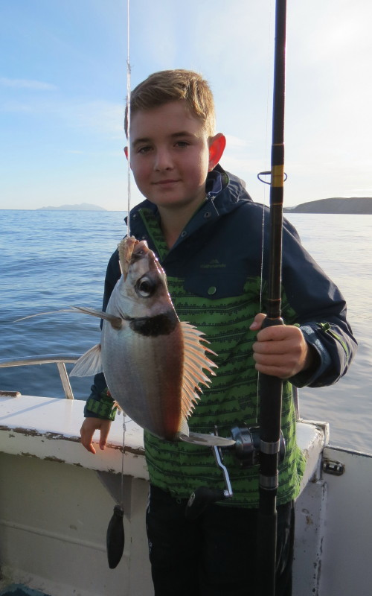
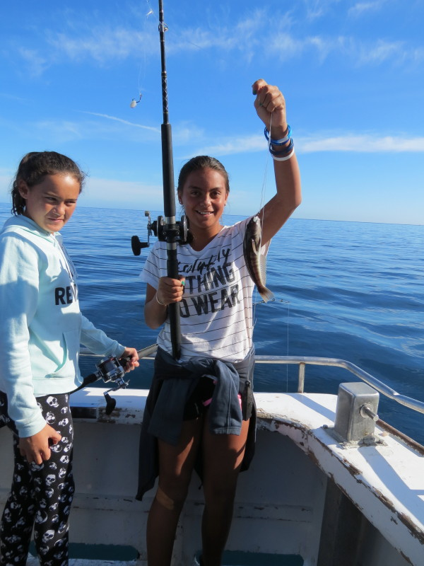
PUKEMANU “TAKE A KID FISHING”

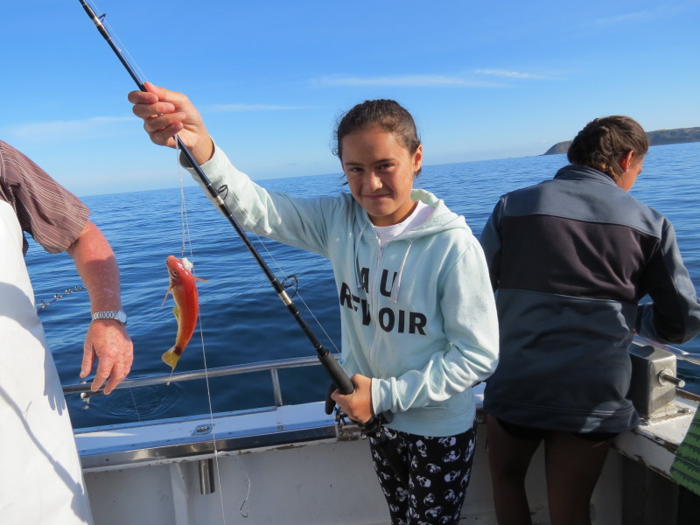
VISION & HEARING SCREENING Thursday 7th April. Regional Public Health Wairarapa provides free vision & hearing screening at your child’s school. Screening will be for:
- Distance vision for Y7 students and those Y8 students who have not completed screening at Y7.
- Colour Vision for Y7 boys.
- Hearing & Distance Vision for 5 & 6yr old children who missed or did not complete their B4 School Checks.
- Children who have transferred schools, who have not yet completed routine vision & hearing screening.
Near vision used for reading books or handwriting is unable to be screened by this service. If you have any concerns please arrange an appoinhtment with an Optometrist.
Please notify your school if you DO NOT agree to your child being screened.
PIRINOA SCHOOL WEBSITE
Every Friday a school newsletter is sent home with your eldest child at school. You can also see the newsletter on our school website under Latest News…check it out.
You will always be up to date with what is happening at our great wee school!!
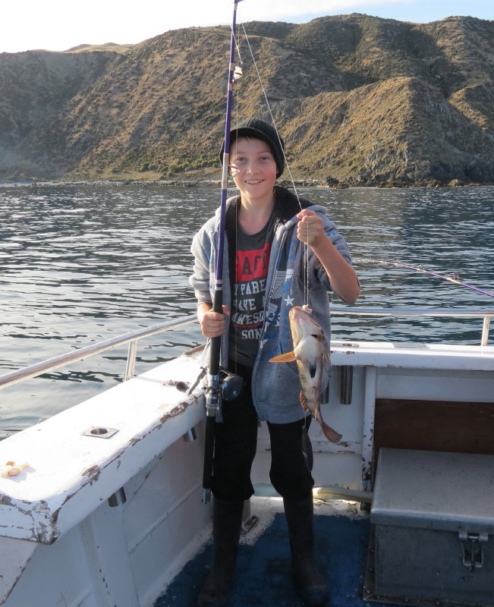
STUDENT AWARDS

ROOM 1: ROWAN ANDERSON for showing respect towards others in the classroom.

ROOM 2: MARSHALL LOVE for a great start to the year with positive behaviour and attitude.

