Pirinoa School ~Vibrant and Successful learning
Te kakama, te momoho o te ako

Newsletter ~ 3rd March 2017 Week 5 Term 1
Principal ~ Pat Ross Tel: 063077829 Fax: 063077510
Email: office@pirinoa.school.nz
Exciting news for the school with the appointment of Matt as permanent Principal starting next term.

Congratulations to our swimmers who represented the school at Featherston this week. By all accounts they had a great day, swimming their hardest, behaving well, cheering each other on and generally making the accompanying adults feel justifiably proud of them. Many thanks to the parents who supplied transport, supervision and timekeeping on the day. It is always much appreciated.

The following children have been entered in the Inter cluster swimming at Featherston next Wednesday 8th March 9.30 am. Charlotte, Edward, Aria, Lucy, Leah, Amanda, Kala.
If parents are unable to transport their child please let me know asap.
Wairarapa Champs will be on March 15th. Qualifying entrants will be notified.

Another big thank you to parents for transport and supervision yesterday when Room 2 went to Wairongomai. This trip transferred a lot of class learning into real life situations.

The term calendar is quite full until the end of term. We will be having informal parent interviews later in the term - more information next newsletter.

Thank you to bus parents who let me know when their child is not on the bus. Much appreciated and saves adding to my grey hairs!!

Have a great week.

Cheers, Pat & Staff.

MARCH
MONDAY | TUESDAY | WEDNESDAY | THURSDAY | FRIDAY | SATURDAY |  | SUNDAY
 |  | 1 | 2 | 3 | 4 |  | 5
6 | 7 | I/school 8  swimming | 9 | 10 | 11 |  | 12
13 | WBC trip to 14  Lake Onoke  Rm 2 only | Swim 15 Champs, Mastn | 16 | 17 | 18 |  | 19
20 | Y7 & 8 Tech21 | 22 | 23 | 24 | 25 |  | 26
27 | Y7 & 8 Tech28 | 29 | 30 | 31

Did you know:
- SAUSAGE SIZZLE: Thank you to those who have put their hand up to cook our sausage sizzles. We are now all sorted for Terms 1 & 2.
- NOTICES: Check out our school noticeboard for classes, activities around our District: tennis, cricket, dance, triathlon, FREE day at Staglands, etc.
- PLEASE NOTE: Students are not to bring lollies to school. Thank you.
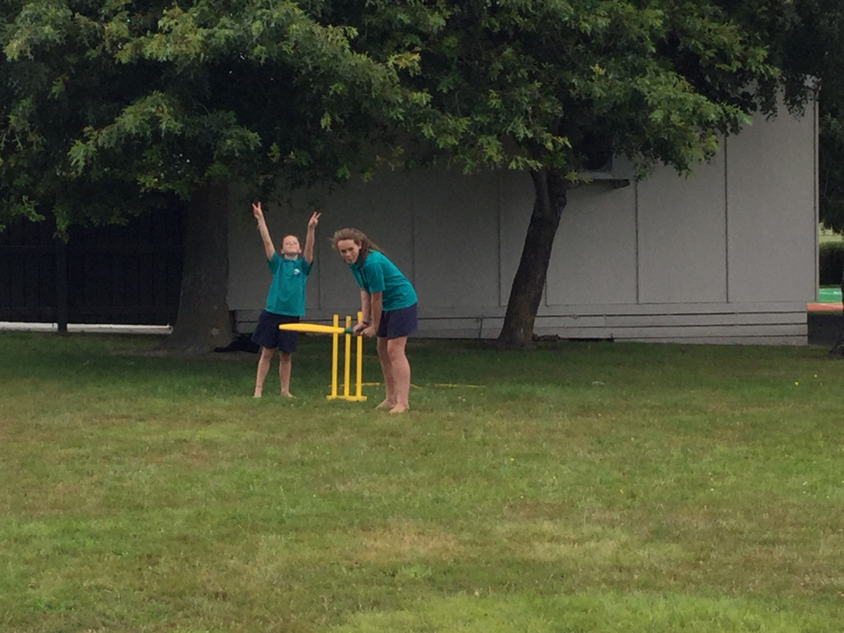
ROOM 1 NEWS

This week Room 1 has been learning about the letter Dd. We have counting in 2s, 5s and 10s. Ordering numbers to 20 and back. The children have made incredible progress in the water. We have some very young students already swimming lengths and the younger students are putting their heads under the water and learning to float. Because of the wonderful work that everybody in Room 1 and 3 are doing in the pool…today we are having a pool party!

IN THE PLAYGROUND……
MARTINBOROUGH FAIR CARPARKING ROSTER – 4TH MARCH 2017.

8am Weatherstone
8.30 am McDowall
9am Williams
9.30am Tipoki
10am Turton
11am Catt
11.30am Macklin/McKelvey
12 noon Robinson
12.30pm Macdonald
1.00pm Hume
2.30pm Baird
A map of the parking & instructions will be on site.

Just a reminder not to bring children under 8 for Health and Safety reasons.

Thank you all for your help with this fundraiser.
WEEK 5 LEARNING AWARDS

PRINCIPAL’S AWARD:
CHARLIE KERRISON-JONES - For your caring attitude to younger children.

ROOM 2: JONO DIDSBURY - For showing leadership skills when finding and recording macro invertebrates from the Wairongomai Stream. Well done, you were very systematic and thorough with your investigation. You are a good role model.

ROOM 1: RYAN JOPE - working hard to follow the routines of the classroom, and,
CALEB LANCELEY – adding by counting on.

ROOM 3: ISABELLA LANCELEY & WILLOW MACDONALD - all round excellence.

PLAYGROUND AWARD: ISABELLA LANCELEY – For learning PB4L.

ROOM 2
Day in the Life of baby Bella
– By Charlie Kerrison-Jones.

Our mum had already left us by the time we had hatched and it was our time to try hard and get back to home base. As we started to head back through the dark water we all slithered across slimy rocks high and low. Every time I looked back our herd got smaller and smaller to the point it was only me and Tim.

The water around was starting to get warm, it was a nice day in November which means whitebait season, we had to be very careful. We are getting close to where our parents came from, this was getting exciting! But our tummies were rumbling with hunger. We smelt food not that far off in this cute little tunnel………

ROOM 2 NEWS

