Pirinoa School ~Vibrant and Successful learning
Te kakama, te momoho o te ako

Newsletter ~ 15th April 2016 Week 11 Term 1
Principal ~ Troy Anderson Tel: 063077829 Fax: 063077510
Email: office@pirinoa.school.nz

Kia Ora

The end of the term has arrived, however the rain hasn't, so hopefully we can get some wet days over the holidays. This week we had a team head away to the Ki-O-Rahi tournament and they did very well, a better result than last year. So well done to all those students and congratulations in coming 3rd. We had two of our year 8’s attend a Year 8 Leadership Camp. They really enjoyed their time away and they shared what they did in assembly today - thank you Shakia and
Te Atawhai. We also had a group of students out collecting native seeds for our tree growing unit, one of the examples of seeds they collected was a Kowhai.

Brag Books are going home today. These books (folders) have a snapshot of what your child/ren have been doing at school. They are not a report, it's just an opportunity for you to sit down with your child/ren so they can share their learning with you.

I hope that everyone has a great holiday, enjoy your time with your children and we will see you all back next term which starts on Monday the 2nd of May.

Troy Anderson
Principal Pirinoa

 |  |  | APRIL
Su |  | Mo |  | Tu | We | Th |  | Fr | Sa
10 |  | 9am World Cup here 11 |  | 12 | Rotary 13 dinner | Ki-O-Rahi 14  Seed collecting  Wairio Wetlands |  | End of T1 15  No sausage sizzle | 16
17 |  | 18 |  | 19 | 20 | 21 |  | 22 | 23
24 |  | 25 |  | 26 | 27 | 28 |  | 29 | 30
 | MAY
Su |  | Mo |  | Tu | We | Th |  | Fr | Sa
1 |  | Start of T2 2 |  | Y7/8 Tech 3 | 4 | Hockey Skills 5 |  | 6 | 7
8 |  | 9 |  | Y7/8 Tech 10  Planting L.Onoke | BOT mtg 11 | Hockey Skills12  Y8Leadership camp |  | Y8Leadership 13  Camp | 14
15 |  | 16 |  | Y7/8 Tech 17 | 18 | Hockey Skills19 |  | 20 | 21
22 |  | 23 |  | Y7/8 Tech 24 | 25 | Hockey Skills26 |  | 27 | 28
29 |  | 30 |  | 31 | June 1 | 2 |  | 3 | 4
 | JUNE
Su |  | Mo |  | Tu | We | Th |  | Fr | Sa
5 |  | Queens B’day 6 |  | ERO Visit 7 | 8 | 9 |  | 10 | 11

Did you know?
- ASSEMBLY: Every Friday at 12.10pm followed by sausage sizzle.
- SAUSAGE SIZZLE: Thank you to CAROLYN JEPHSON who will be cooking our sausage sizzle on 6th May.
- POOL KEYS: Please return pool keys before the end of term, Friday 15th April. Thank you.
Our Ki-o-Rahi Champions 2016
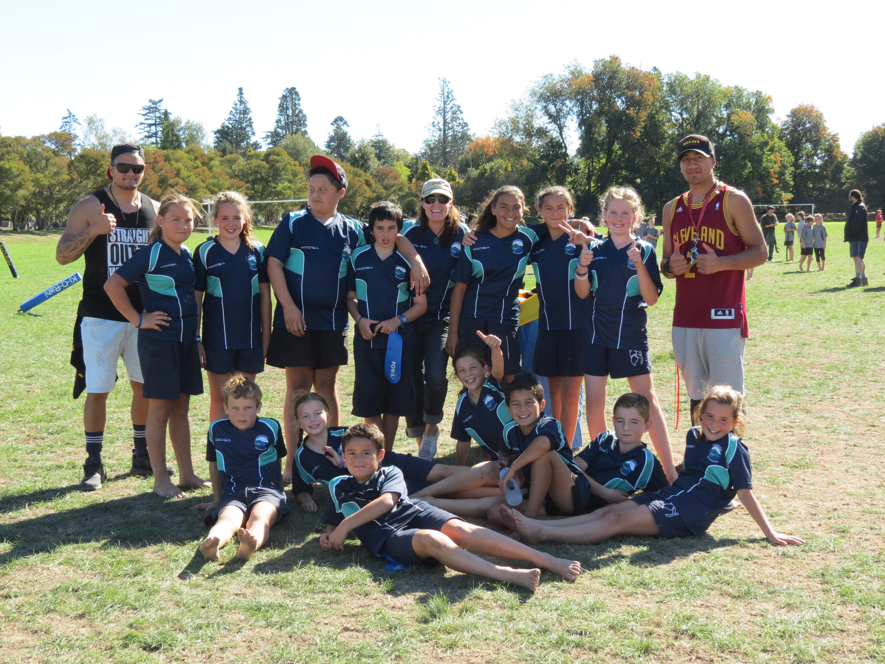
ANZAC DAY Monday 25th April at
10.30am at the Flagpole. Pirinoa
School will be laying a wreath at
the ceremony and we would love to
see our students there (in full school
uniform please).
ROOM 2 NEWS
This Week in Room 2 it was awesome. We had a lot of fun. We went to play in a Ki-o-Rahi tournament, it was awesome, we came 3rd against some other massive schools.
On Monday the real rugby World Cup came to our school for a visit.
On Wednesday it was the Rotary Dinner. Nikau, Kingston, Zac, Shakia, Kala, Indy, Whai, Isla, Edward and I all went to the Rotary dinner to help serve and eat all the leftovers hahahahaha!
We had a good week and we come back to school in two weeks after the holidays.

By Marshall.

YEAR 7/8 BASKETBALL
We are looking at a school year 7/8 basketball team which will be played on Wednesday nights at Kuranui college 3.30 - 6pm. If your child is interested please let Troy know by Friday the 23rd April. Text: 0275181987.

CAN YOU HELP PLEASE?
We need things for the School Garden
- Ice cream containers
- Empty 2 litre containers
- An old gate (rusty or slightly broken would be ok)
- More tyres
ROOM 1 WEEKLY NEWS.
Today we are remembering Poppy Day. We
are designing poppies and learning about
ANZAC Day. The older students in Room 1 are
researching about ANZAC day!
We hope everybody has a great holiday..see
you next Term.
ROTARY DINNER
Many thanks for all those who helped make the Rotary Dinner another great success, especially to Alex and Donna for all the organisation and running around!!

STUDENT AWARDS

PRINCIPAL AWARD: MARALYSE WHITEMAN - Maralyse, you have an awesome attitude towards learning, you have impressed everyone with your hard work and kind, caring nature
towards others. Ka Pai, well done.

ROOM 1: ROWAN ANDERSON - for having a positive attitude during House Challenges.

ROOM 2: JACK McDOWALL - for his amazing effort at the Ki-o-Rahi tournament even with a wounded knee and for a great start to Pirinoa School in general.

PIRINOA SCHOOL WEBSITE
Every Friday a school newsletter is sent home with your eldest child at school. You can also see the newsletter on our school website under Latest News…check it out.
You will always be up to date with what is happening at our great wee school!!

