Pirinoa School ~Vibrant and Successful learning
Te kakama, te momoho o te ako

Newsletter ~ 31st March 2017 Week 9 Term 1
Principal ~ Pat Ross Tel: 063077829 Fax: 063077510
Email: office@pirinoa.school.nz

A big welcome to Jesse and Skye who have now started school bringing our roll to 40 children.
Only nine more school days to the end of term.
The Room 2 children enjoyed their Science and Technology trip to Masterton. Thanks once again to those parents who provided the transport and assistance –also their Field Trip.
Thank you to the parents who came and had a chat about their child’s progress this term. It’s always good to be working together towards the same goals for the children.
PB4L trip this term is to the Glow worms at Ruakokopatuna on Monday 10th -Permission and Transport forms attached-please return on Monday.
Small Sticks and Hockey coaching went well yesterday and we have 1 more session of both this term.
The final newsletter of the term will go out on Thursday 13th April.

Have a great week.
Cheers
Pat

MARCH
MONDAY | TUESDAY | WEDNESDAY | THURSDAY | FRIDAY | SATURDAY |  | SUNDAY
Scholastic book orders due 20 | Y7 & 8 Tech 21  Mboro 11aside  Trials. | 22 | 23 | 24 | 25 |  | 26
Rm 2 only 27  Science Roadshow | Y7 & 8 Tech 28  BOT meeting | 29 | 30 | BBQ @ 31  school 5.30pm – welcome. | APRIL 1 |  | 2
3 | Y7 & 8 Tech 4 | 5 | 6 | 7 | 8 |  | 9
PB4L Trip to 10  Glow worm caves | Y7 & 8 Tech 11 | Postponemt PB4L Trip 12 | End of 13 Term | SCHOOL 14  HOLIDAYS | 15 |  | 16
17 | 18 | 19 | 20 | 21 | 22 |  | 23
24 | ANZAC DAY 25  10.30am at Flagpole | 26 | 27 | 28 | 29 |  | 30
MAY 1  Term 2 starts | 2 | 3 | 4 | 5 | 6 |  | 7

Did you know:
- SAUSAGE SIZZLE: 7th April – Tashiana;
13th April – Kara.
We will be having a sausage sizzle on the last day of school, even though it is a Thursday. Thanks Kara for stepping into the gap!!
- DON’T FORGET: Welcome BBQ for Matt and Monique this evening, 5.30pm at school. BYO something for the BBQ.
- POOL KEYS: Pool keys due back by Monday 3rd April. Upon receipt, a $10 bond will be sent to you. Thank you.
- M’BORO SQUASH CLUB: Coaching sessions Mondays from 3.30pm, Club night/matches Friday from 4.30pm in terms 2 & 3. All ages and levels catered for. Club registration – Monday 27th March 4pm at Squash Club at Martinborough Golf Club or email: lynettenetty@outlook.com
Active in the playground
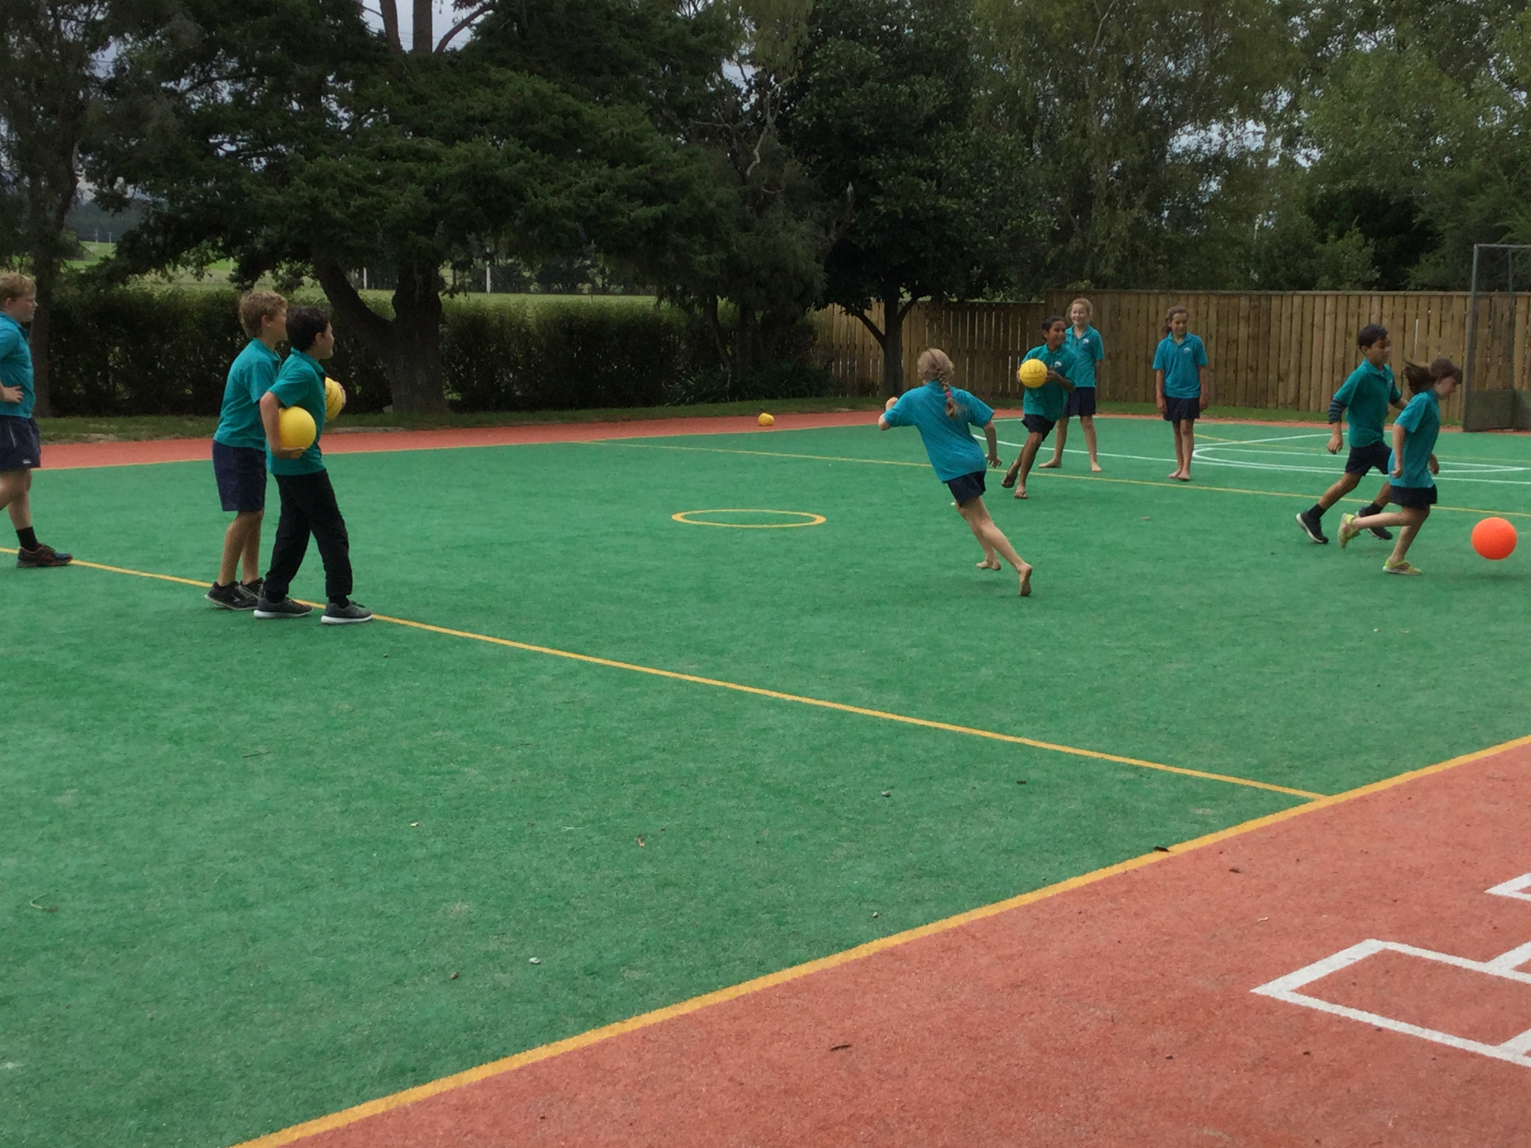
1Active in the playground

Figure 2Active in the playground

ROOM 1 NEWS
This week we had the small sticks teach us hockey skills and Rugby Wairarapa teach us rugby skills.
We have started to get ready for Cross-country which will be happening next term. The children are enjoying running fast and encouraging each other to do their best.
A big welcome to Skye Macdonald and Jesse Hedgecock who have both turned five.

ROOM 2

Andy Warhol style art produced from a photograph – By Maralyse Whiteman.
Reminder: Southern Netball Y3-8 Trials
Monday 3rd April, Martinborough School. We are excited with the increase in players and look forward to seeing everyone there.
Congratulations to all our Y1 & 2’s who have been doing netball at Kuranui College on Wednesdays, your last day will be Wed 12th April where there will be a mini tournament. Please remember to bring along your $20 sub if you have not already paid and that if the weather is very cool or wet we can be found in the college gym.
ANZAC DAY
It would be fantastic to see our students down at Lake Ferry for the ceremony – in full uniform please!! Gather for service at the Flagpole at 10.30am Tuesday 25th april, then onto Lake Ferry Hotel for the speaker. If weather is adverse it will all be held at the Hotel.
A plateA
WEEK 5 LEARNING AWARDS

PRINCIPAL’S AWARD: MAIYAH FELLERHOFF – For showing resilience.

ROOM 2: POLLY TELFORD - For demonstrating a positive attitude and consistently making positive comments about completing your work in Mathematics.

ROOM 1: JACOB MANZE – For showing resilience when playing rugby.

ROOM 3: KATIE HOPKINS – For great reading.

PLAYGROUND AWARD: CHARLIE
KERRISON-JONES – For using manners towards teachers.

ROOM 2 NEWS

