Pirinoa School ~Vibrant and Successful learning
Te kakama, te momoho o te ako

Newsletter ~ 13th April 2017 Week 11 Term 1
Principal ~ Pat Ross Tel: 063077829 Fax: 063077510
Email: office@pirinoa.school.nz
Wow - last day of term! Even though it was long, the time seems to have flown.

We had a great trip to the Glow Worm caves on Monday. I loved the adventure and even getting wet to the, shall we say, waist! Great parent support as usual and needed with the depth of water. Many thanks to you all and to Sissy for organising it.

Thank you all for a very pleasant term. I’ve enjoyed working with the children, BoT, parents and community and hope I’ve helped tick things over. Last but not least all the staff. It’s been great actually having staff to share the load, brainstorm ideas and just chat with.

The children are very lucky to have such a well supported school, not only by parents but community members who help in many ways.

I wish you all the very best for the future with Matt and will keep an eye on the Facebook page to see what the children are up to.

Have a happy and safe Easter. Term 2 starts Monday 1st May 2017.

Cheers
Pat

APRIL
MONDAY | TUESDAY | WEDNESDAY | THURSDAY | FRIDAY | SATURDAY |  | SUNDAY
PB4L Trip to 10  Glow worm caves | Y7 & 8 Tech 11 | Postponemt PB4L Trip 12 | End of 13 Term | SCHOOL 14  HOLIDAYS | 15 |  | 16
17 | 18 | 19 | 20 | 21 | 22 |  | 23
24 | ANZAC DAY 25  10.30am at Flagpole | 26 | 27 | 28 | 29 |  | 30
MAY
Term 2 starts 1 | 2 | 3 | Small sticks 4 | Mufti Day 5  Gold coin for Chopper Appeal 5 | 6 |  | 7
8 | 9 | 10 | Small sticks11 | 12 | 13 |  | 14
15 | 16 | Year 8 17  NYLD | 18 | 19 | 20 |  | 21
22 | Board meeting 23 | 24 | 25 | 26 | 27 |  | 28
29 | Yr 7/8 Tech 30 | 31 | June 1 | 2 | 3 |  | 4

Did you know:
- SAUSAGE SIZZLE: 5th May – Jephsons
- 12th May – Macdonalds. Thank you.
- POOL KEYS: There are still a number of pool keys that have not been returned. The pool is closed. Please ensure you return your key asap. Upon receipt, a $10 bond will be sent to you. Thank you.
An Anzac presentation from our students.
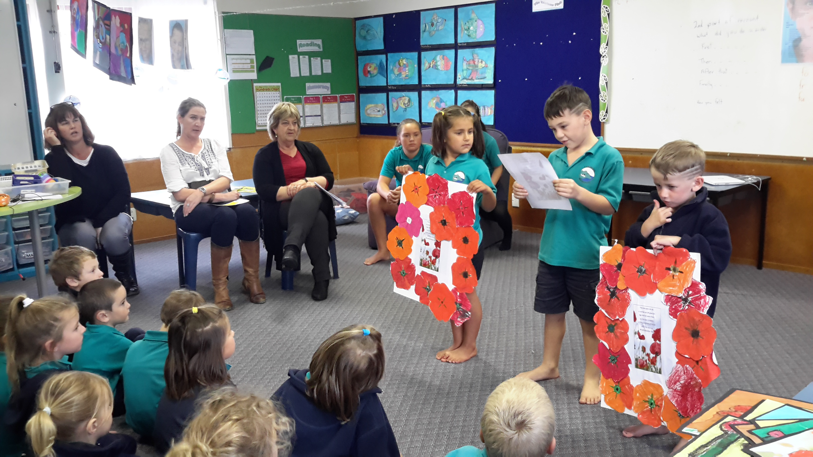
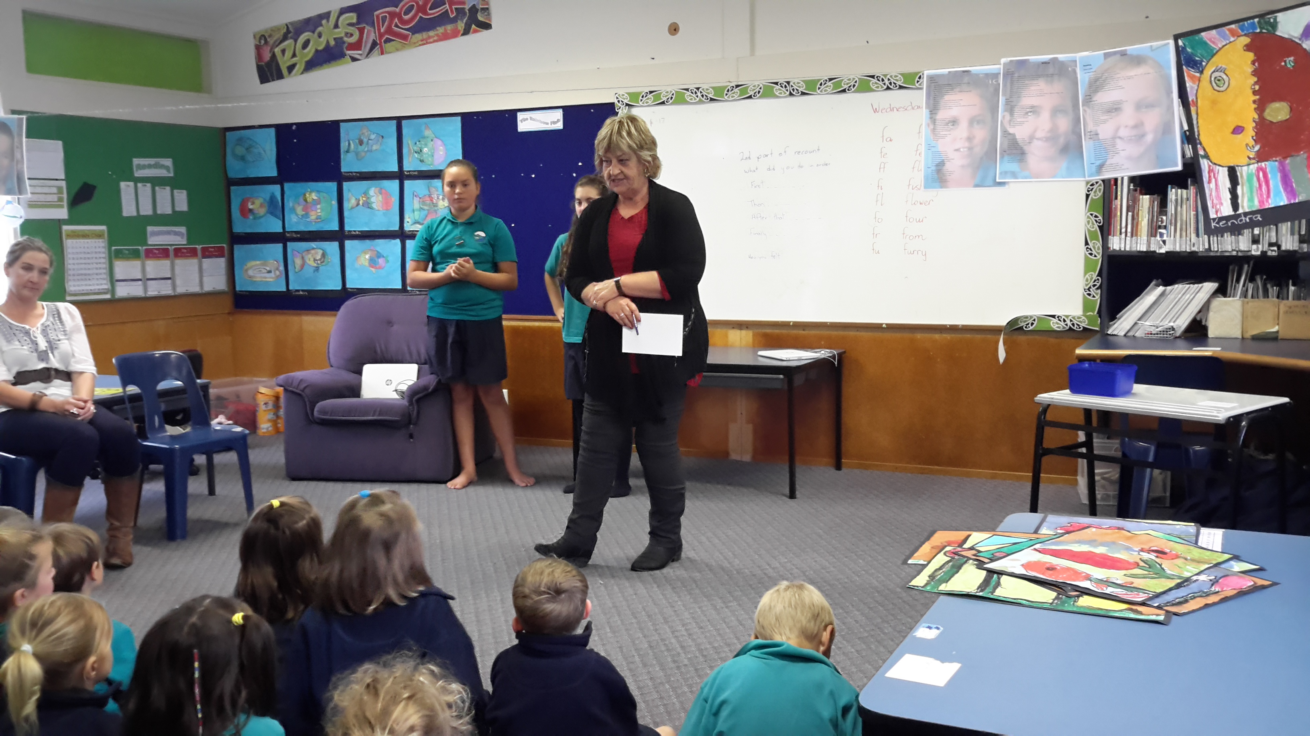
Hunting & Fishing Homewood Claybird Shoot
Sunday 30th April at Homewood Marae. 9am start. Last entries 10.30am. Cost $50 pp
Hot food available all day. 70 targets for the day. Ammunition available on the day. Lots of spot prizes. Homewood Flurry at end of day after prizegiving.
Funds raised will support Whareama School & Playgroup. Contact George (06) 3723609.
ROOM 1 STORIES.
We are having an Easter Egg Hunt.
- By Jayziah.
I love all Easter Eggs.
- By Ryan.
I am eating a chocolate Easter bunny.
- By Jesse.
I am waiting for Easter.
- By Caleb.
I went to the supermarket and I got an Easter egg.
- By Skye.
I can’t wait for Easter.
- By Jacob.
I saw some glow worms and I had some lunch.
- By Vienna.

ROOM 2
On Monday we all went to the glow worms. When we got there we waited at the river, we went last. In my group there was Maralyse, Ursula, Polly, Olivia, Jordan and Jana.
When we finally went in the cave it was very deep then it got shallower. In the middle I slipped. We saw blue glow worms, they looked like rocks that glow on the top of the cave. At the end it was deep again. When we got out we were wet. At the end we went again that time I didn’t slip over.
By Aria Whiteman.

ANZAC DAY
Gather for service at the Flagpole at 10.30am Tuesday 25th April, then onto Lake Ferry Hotel for the speaker. If weather is adverse it will all be held at the Hotel. A plate for afterwards would be appreciated please.
It would be fantastic to see our students down at Lake Ferry for the ceremony. We will be placing a wreath at the Flagpole and some of our students may be reading out their poems.
Please ensure our students wear their Full uniform. Thank you.
A huge thankyou to Mrs Ross for holding us altogether this Term. Have fun at your new posting and keep in touch!!
WEEK 11 LEARNING AWARDS

PRINCIPAL’S AWARD:
KENDRA WELLS - Being responsible and showing leadership

ROOM 2: AMANDA JEPHSON - For following the Pirinoa Path. You always try your very best with everything you do and complete your work to a high standard. You are a pleasure to teach.

ROOM 1:
RYAN JOPE - Finishing work on time.
SKYE MACDONALD - For always showing kindness towards others.

ROOM 3:
URSULA WHITEMAN - Great Reading and Writing.

PLAYGROUND AWARD: JESSE HEDGECOCK – For being kind while jumping on the trampoline.

ROOM 2 NEWS

